**BJJD- Spring Microservices**

# Project Architecture

We are going to create a Spring Microservices which is based on Spring Boot. It uses Spring Cloud and kubernetes dependencies as well. There are following microservices we are going to develop:

1. **Config-server** (will not use parent pom):
2. **eureka-server** (will not use parent pom):This application is developed to register all the microservices. So that every microservice can communicate with each other without knowing their IP address of the microservice.
3. **gateway-service:** A gateway is a single-entry point into the system, used to handle requests by routing them to the corresponding microservice.
4. **common-service** (will not use parent pom): It is library which will be used by other microservices.
5. **auth-service**
6. **project-service:**
7. **people- service:**
8. **account-service:**
9. **data-upload-service**
10. **cache-service**
11. **message-sender-service**
12. **Kafka-producer-service**
13. **Kafka-consumer-service**
14. **k8s:** It contains the common files used in Kubernetes.

**Following implementation in details:**

* Cache using Hazelcast (Embedded Distributed Cache)
* Sleuth and Zipkin
* Istio (Service Mesh: Sidecar Container: Grafana, Kaili and Distributed tracing using Jager)
* ELK(Stack)
* Helm
* **Microservices in Dev Environment**

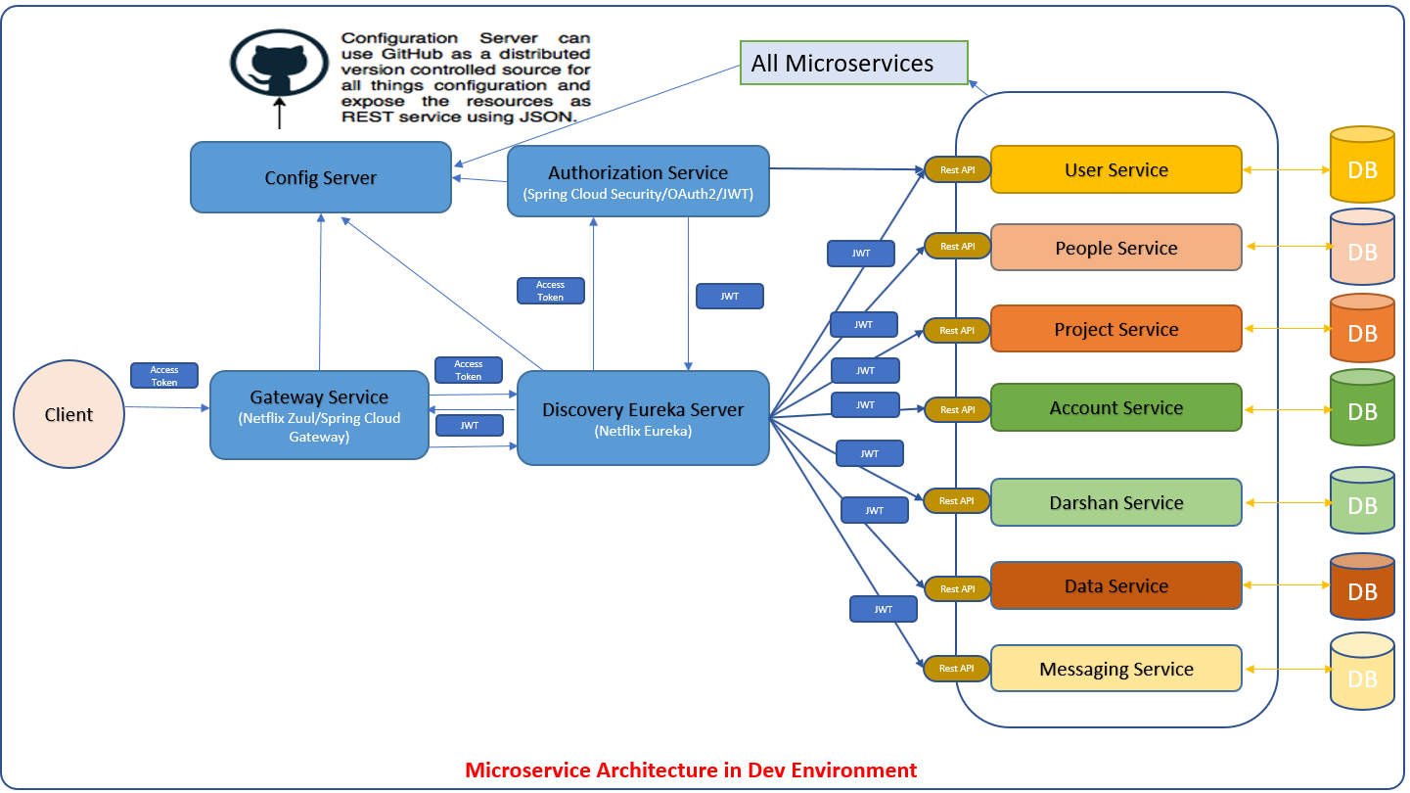

* 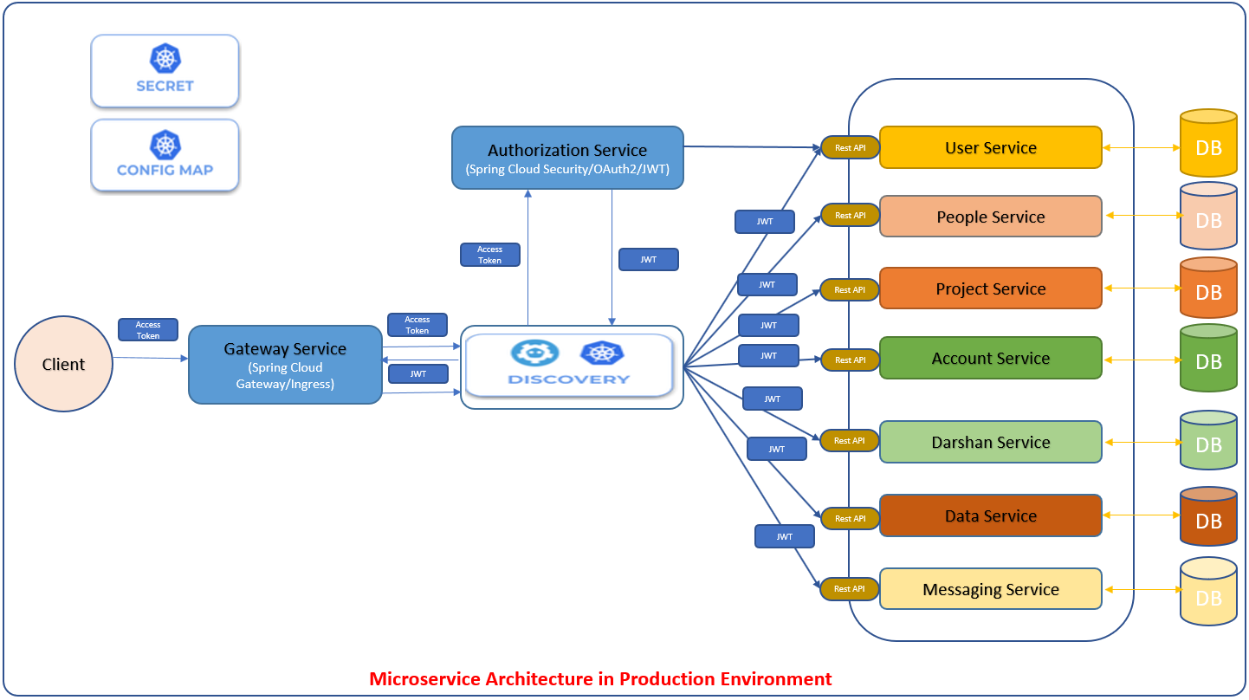**Microservices in Production Environment (Kubernetes)**
* **Multi Module Project**

We are going to create a Spring Microservices multi module project as shown in the diagram below

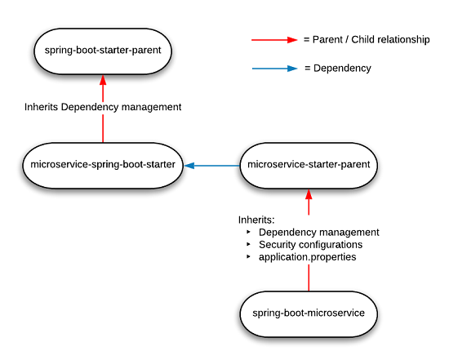

**Parent pom.xml**

Parent pom.xml will be inherited by other microservices.

* + Spring Cloud Starter Config: This dependency is required to connect to the Config Server
  + Spring Boot Starter Parent: update the version: 2.2.4.RELEASE highlighted in yellow colour.
  + Spring Cloud version: upgraded to Hoston.SR4. It is highlighted in yellow colour.
  + Maven Jar Plugin Version: After the above updates, pom is giving compiler error in pom.xml so downgraded version of maven jar plugin to 3.1.1. It is highlighted in yellow colour.
  + Lombok: For getters, setters and constructors etc.
  + Profiles: There are two profiles configured in maven
    1. Dev:
       1. It will pull the application configuration properties from config server.
       2. It will use Eureka Server
       3. It will use the mysql database locally.
       4. It will not use Kubernetes discovery strategy for Hazelcast cache
    2. Prod:
       1. Eureka client will be disable and it will not use Eureka Server to discover any other microservices. It will use Kubernetes discovery client to disc
       2. configure the Kubernetes Discovery Strategy. this configuration will form a Hazelcast with all Hazelcast instances assigned to services in the current namespace.
       3. It will use the mysql AWS database remotely.

<project xmlns=*"http://maven.apache.org/POM/4.0.0"* xmlns:xsi=*"http://www.w3.org/2001/XMLSchema-instance"*

xsi:schemaLocation=*"http://maven.apache.org/POM/4.0.0 http://maven.apache.org/xsd/maven-4.0.0.xsd"*>

<modelVersion>4.0.0</modelVersion>

<groupId>com.jmk</groupId>

<artifactId>bjjd-microservices</artifactId>

<version>0.0.1-RELEASE</version>

<packaging>pom</packaging>

<parent>

<groupId>org.springframework.boot</groupId>

<artifactId>spring-boot-starter-parent</artifactId>

<version>2.2.4.RELEASE</version>

<relativePath /> <!-- lookup parent from repository -->

</parent>

<properties>

<java.version>11</java.version>

<maven.compiler.source>${java.version}</maven.compiler.source>

<maven.compiler.target>${java.version}</maven.compiler.target>

<springfox-version>2.7.0</springfox-version>

<hibernate.version>5.4.10.Final</hibernate.version>

<spring-cloud.version>Hoxton.SR4</spring-cloud.version>

<maven-jar-plugin.version>3.1.1</maven-jar-plugin.version>

<jmk-version>0.0.1-RELEASE</jmk-version>

</properties>

<dependencies>

<!-- Spring Boot Starter Dependencies -->

<dependency>

<groupId>org.springframework.boot</groupId>

<artifactId>spring-boot-starter-web</artifactId>

</dependency>

<dependency>

<groupId>org.springframework.boot</groupId>

<artifactId>spring-boot-starter-tomcat</artifactId>

</dependency>

<!-- Actuator is mainly used to expose operational information about the

running application — health, metrics, info, dump, env, etc. -->

<dependency>

<groupId>org.springframework.boot</groupId>

<artifactId>spring-boot-starter-actuator</artifactId>

</dependency>

<!-- Spring Cloud Starter Dependencies -->

<!-- Spring Cloud Starter Config is required to connect config server -->

<dependency>

<groupId>org.springframework.cloud</groupId>

<artifactId>spring-cloud-starter-config</artifactId>

</dependency>

<!-- Spring Cloud Starter Kubernetes is required for Kubernetes -->

<dependency>

<groupId>org.springframework.cloud</groupId>

<artifactId>spring-cloud-starter-kubernetes-all</artifactId>

<!-- <version>1.1.2.RELEASE</version> -->

</dependency>

<!-- Distributed Logging Api -->

<dependency>

<groupId>org.springframework.cloud</groupId>

<artifactId>spring-cloud-starter-sleuth</artifactId>

</dependency>

<!-- Spring Hystrix : Circuit Breaker-->

<dependency>

<groupId>org.springframework.cloud</groupId>

<artifactId>spring-cloud-starter-netflix-hystrix</artifactId>

</dependency>

<!-- Spring Open Feign Client -->

<dependency>

<groupId>org.springframework.cloud</groupId>

<artifactId>spring-cloud-starter-openfeign</artifactId>

</dependency>

<!-- Spring Cloud Netflix Eureka Client -->

<dependency>

<groupId>org.springframework.cloud</groupId>

<artifactId>spring-cloud-starter-netflix-eureka-client</artifactId>

</dependency>

<!-- Spring Netflix ribbon LoadBalancer -->

<dependency>

<groupId>org.springframework.cloud</groupId>

<artifactId>spring-cloud-starter-netflix-ribbon</artifactId>

</dependency>

<!--SpringFox dependencies -->

<dependency>

<groupId>io.springfox</groupId>

<artifactId>springfox-swagger2</artifactId>

<version>${springfox-version}</version>

</dependency>

<dependency>

<groupId>io.springfox</groupId>

<artifactId>springfox-swagger-ui</artifactId>

<version>${springfox-version}</version>

</dependency>

<dependency>

<groupId>com.github.joschi.jackson</groupId>

<artifactId>jackson-datatype-threetenbp</artifactId>

<version>2.6.4</version>

</dependency>

<!-- Lombok data -->

<dependency>

<groupId>org.projectlombok</groupId>

<artifactId>lombok</artifactId>

<scope>provided</scope>

</dependency>

<!-- spring-boot-starter-test “Starter”, which imports both Spring Boot

test modules as well as JUnit, AssertJ, Hamcrest, and a number of other useful

libraries. -->

<dependency>

<groupId>org.springframework.boot</groupId>

<artifactId>spring-boot-starter-test</artifactId>

<scope>test</scope>

</dependency>

</dependencies>

<dependencyManagement>

<dependencies>

<dependency>

<groupId>org.springframework.cloud</groupId>

<artifactId>spring-cloud-dependencies</artifactId>

<version>${spring-cloud.version}</version>

<type>pom</type>

<scope>import</scope>

</dependency>

</dependencies>

</dependencyManagement>

<profiles>

<profile>

<id>dev</id>

<activation>

<activeByDefault>true</activeByDefault>

</activation>

<properties>

<spring.profiles.active>dev</spring.profiles.active>

</properties>

</profile>

<profile>

<id>prod</id>

<properties>

<spring.profiles.active>prod</spring.profiles.active>

</properties>

</profile>

</profiles>

<build>

<sourceDirectory>src/main/java</sourceDirectory>

<plugins>

<plugin>

<groupId>org.springframework.boot</groupId>

<artifactId>spring-boot-maven-plugin</artifactId>

<executions>

<execution>

<goals>

<goal>repackage</goal>

</goals>

</execution>

</executions>

</plugin>

</plugins>

</build>

<modules>

<module>common-service</module>

<module>user-service</module>

<module>project-service</module>

<module>account-service</module>

<module>darshan-service</module>

<module>data-upload-service</module>

<module>eureka-server</module>

<module>message-sender-service</module>

<module>people-service</module>

<module>config-server</module>

<module>auth-service</module>

<module>gateway-service</module>

<!-- Additional Modules -->

<module>kafka-producer-service</module>

<module>kafka-consumer-service</module>

<module>cache-service</module>

</modules>

</project>

# Config-server

This application is used to externalize properties or resource files out of server where the values of those resources vary during runtime – usually different configurations that will differ in each environment.

1. Create the config server – It will point to config server git repository and will provide the access of the all the properties to its related microservice.
2. Create the config server git repo – It will maintain the application.properties of the microservices.
3. Update the microservices to point config server – To make changes in the new or existing microservice so that it can access its application .properties using config server.

### **A. Create the config server**

* Create Spring Boot Project



* Click on next



* **Select the dependencies: Spring Cloud Config – Config Server and Click on Finish.**



* **Import the project in eclipse.**



* Dependencies already imported can be seen in pom.xml but need to update with the following changes
  + Spring Cloud Config server: This dependency is required to configure the config server along with dependency management circled in blue colour in the below picture.
  + Spring Boot Starter Parent: update the version - 2.2.4.RELEASE highlighted in yellow colour.
  + Spring Cloud version: upgraded to Hoston.SR4. It is highlighted in yellow colour.
  + Maven Jar Plugin Version: After the above updates, pom is giving compiler error in pom.xml so downgraded version of maven jar plugin to 3.1.1. It is highlighted in yellow colour.

<?xml version=*"1.0"* encoding=*"UTF-8"*?>

<project xmlns=*"http://maven.apache.org/POM/4.0.0"* xmlns:xsi=*"http://www.w3.org/2001/XMLSchema-instance"*

xsi:schemaLocation=*"http://maven.apache.org/POM/4.0.0 https://maven.apache.org/xsd/maven-4.0.0.xsd"*>

<modelVersion>4.0.0</modelVersion>

<parent>

<groupId>org.springframework.boot</groupId>

<artifactId>spring-boot-starter-parent</artifactId>

<version>2.2.4.RELEASE</version>

<relativePath/> <!-- lookup parent from repository -->

</parent>

<groupId>com.jmk</groupId>

<artifactId>config-server</artifactId>

<version>0.0.1-RELEASE</version>

<name>config-server</name>

<description>Config Server</description>

<properties>

<java.version>11</java.version>

<spring-cloud.version>Hoxton.SR4</spring-cloud.version>

<maven-jar-plugin.version>3.1.1</maven-jar-plugin.version>

</properties>

<dependencies>

<dependency>

<groupId>org.springframework.cloud</groupId>

<artifactId>spring-cloud-config-server</artifactId>

</dependency>

<dependency>

<groupId>org.springframework.boot</groupId>

<artifactId>spring-boot-starter-actuator</artifactId>

</dependency>

<dependency>

<groupId>org.springframework.boot</groupId>

<artifactId>spring-boot-starter-test</artifactId>

<scope>test</scope>

</dependency>

</dependencies>

<dependencyManagement>

<dependencies>

<dependency>

<groupId>org.springframework.cloud</groupId>

<artifactId>spring-cloud-dependencies</artifactId>

<version>${spring-cloud.version}</version>

<type>pom</type>

<scope>import</scope>

</dependency>

</dependencies>

</dependencyManagement>

<build>

<plugins>

<plugin>

<groupId>org.springframework.boot</groupId>

<artifactId>spring-boot-maven-plugin</artifactId>

</plugin>

</plugins>

</build>

</project>

* **Enable the annotation @EnableConfigServer**



* **Update the application.properties with the git repository will be created in this section after this step.**



### **B. Create the config server git repo**

The next essential step is to create a local git repository. It can easily be converted to a remote repository later by configuring its URL in the properties file. We will place the external property file [configuration], which will be used by the Config server microservice to provide the external configuration of properties.

* Make sure you have git shell installed in your machine and you can run git bash from command prompt. To verify it open command prompt and type git, if it recognizes the command then you probably have the git prompt installed, if not please follow git website, download and install as per the instruction.
* Now Create a directory **bjjd-config-server-git-repo** in location: C:\Users\rkbansal\git\bjjd-config-server-git-repo
* Create microservice name wise folder in **bjjd-config-server-git-repo**. For example:



* Structure of any project can be seen:



* Let’s look into any properties file. For e.g. application.properties of people-mgmt-service



* Open the command prompt and go to the **bjjd-config-server-git-repo** in location: C:\Users\rkbansal\git\bjjd-config-server-git-repo
  + Git Command to initialize the git repository:
    - git init
  + Git command to add the code in the git repository:
    - Git add .
  + Git command to commit the code in the git repository:
    - Git commit -m “Initial Commit”



* After creating the git repository, it can be imported in Eclipse as GIT repository and as a General Project.



* Import as a General Project



* This project can be seen in eclipse



* Point the git repo from Config Server

Update the application.properties in the src\main\resources directory of spring-config-sever project and add below lines.



* To verify the Config server configuration, run the Config Server application and check the following URL:
  + URL to check the dev properties of people-mgmt-service : <http://localhost:8888/people-mgmt-service/dev>



* + URL to check the prod properties of people-mgmt-service : <http://localhost:8888/people-mgmt-service/prod>



### **C. [Optional]Move the local config server git repo to GitHub**

1. After performing the step B.
2. Follow the below steps to create the remote, empty folder/repository in GitHub named:
   1. Login to your GitHub account.
   2. At the top right of any GitHub page, you should see a '+' icon. Click that, then select 'New Repository'.
   3. Give your repository a name--ideally the same name as your local project. If I'm building a **bjjd-config-server-git-repo**  application, its folder will be called '**bjjd-config-server-git-repo**' on my computer, and ' **bjjd-config-server-git-repo**' will be the GitHub repository name as well.
   4. Click 'Create Repository'. The next screen you see will be important, so don't close it.

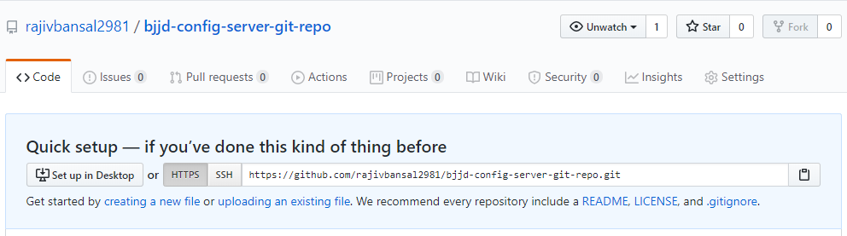

1. Connect your local project folder to your empty folder/repository(https://github.com/rajivbansal2981/bjjd-config-server-git-repo.git) on GitHub
   1. Go back to your project in the terminal/command line.

cd C:\Users\rkbansal\git\bjjd-config-server-git-repo

* 1. In your terminal/command line, type git remote add origin [copied web address]

git remote add origin <https://github.com/rajivbansal2981/bjjd-config-server-git-repo.git>

* 1. Push your branch to GitHub and provide user id and password when prompted

git push origin master

* 1. Go back to the folder/repository screen on Github that you just left, and refresh it you should see your files there.

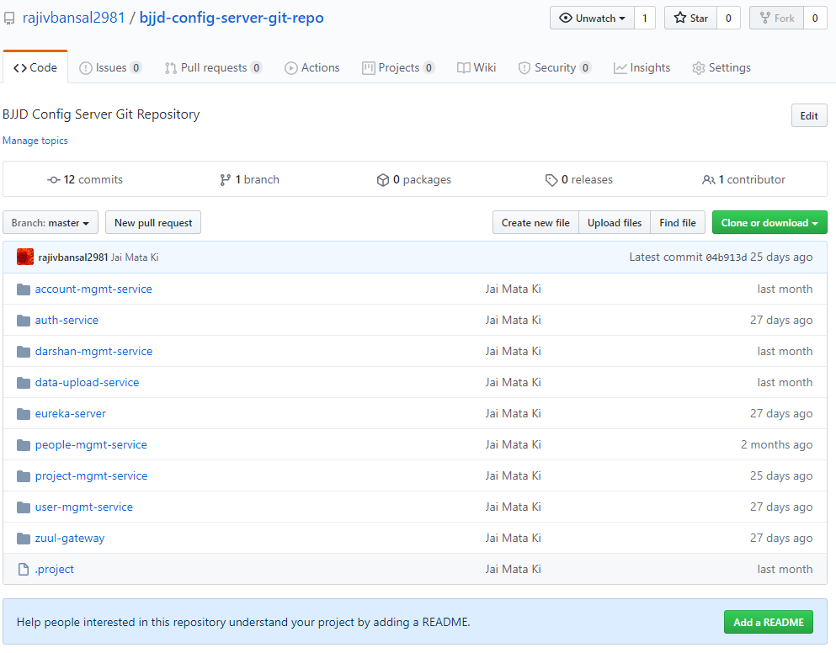

1. To update the application.properties of project: config-server and enable the git URI path for GitHub

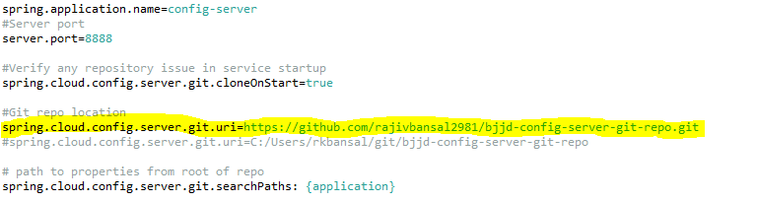

4. Connect your l

### **D.Update the microservices to point config server**

In this step, we need to make changes in the new or existing microservices so that it can access its application.properties using config server.

**For example:** people-mgmt-service

**Perquisite:** people-mgmt-service’s pom should be updated with the following changes:

* + Spring Cloud Starter Config: This dependency is required to connect to the Config Server
  + Spring Boot Starter Parent: update the version : 2.2.4.RELEASE highlighted in yellow colour.
  + Spring Cloud version: upgraded to Hoston.SR4. It is highlighted in yellow colour.
  + Maven Jar Plugin Version: After the above updates, pom is giving compiler error in pom.xml so downgraded version of maven jar plugin to 3.1.1. It is highlighted in yellow colour.
* Need to make the changes in pom.xml of people-mgmt-service





* Moved the main application.properties along with different profiles to git repository: **bjjd-config-server-git-repo**



* In the people-mgmt-service, still there will be an application.properties file but it will have following minimum details:
  + Name of the application
  + Active default profile
  + Cloud config server URI with port



* To verify all the changes, run the following applications in the order:
  + ConfigServerApplication
  + EurekaServerApplication
  + PeopleMgmtRestApplication

Directly hitting the people-mgmt-project running on 6379 and fetch the member details based on the id



# Eureka-server

Eureka Server or service will register every microservice and then the client microservice will look up the Eureka server to get a dependent microservice to get the job done without knowing the IP address of dependent microservice.

Eureka Server is owned by Netflix and in this, Spring Cloud offers a declarative way to register and invoke services by Java annotation.

It’s duty to give names to each microservice. Why?

* No need to hardcode the IP addresses of microservices.
* What if services use dynamic IP addresses; when autoscaling.

So, every service register itself with Eureka, and pings Eureka server to notify that it’s alive.

This application is developed to register all the microservices. So that every microservice can communicate with each other without knowing their IP address of the microservice.

* Create Spring Boot Project



* Click on next



* Click on **Next** and **Finish** and created project will look as per the below screenshot:



* Add the following dependencies in pom.xml with the following considerations:
  + Spring Cloud Starter Config: This dependency is required to connect to the Config Server
  + Spring Boot Starter Parent: update the version: 2.2.4.RELEASE highlighted in yellow colour.
  + Spring Cloud version: upgraded to Hoston.SR4. It is highlighted in yellow colour.
  + Maven Jar Plugin Version: After the above updates, pom is giving compiler error in pom.xml so downgraded version of maven jar plugin to 3.1.1. It is highlighted in yellow colour.
  + Web
  + Eureka Server
  + DevTools (optional)

<?xml version=*"1.0"* encoding=*"UTF-8"*?>

<project xmlns=*"http://maven.apache.org/POM/4.0.0"*

xmlns:xsi=*"http://www.w3.org/2001/XMLSchema-instance"*

xsi:schemaLocation=*"http://maven.apache.org/POM/4.0.0 http://maven.apache.org/xsd/maven-4.0.0.xsd"*>

<modelVersion>4.0.0</modelVersion>

<parent>

<groupId>org.springframework.boot</groupId>

<artifactId>spring-boot-starter-parent</artifactId>

<version>2.2.4.RELEASE</version>

<relativePath/> <!-- lookup parent from repository -->

</parent>

<groupId>com.jmk</groupId>

<artifactId>eureka-server</artifactId>

<version>0.0.1-RELEASE</version>

<name>eureka-server</name>

<description>Demo project for Spring Boot</description>

<properties>

<java.version>11</java.version>

<spring-cloud.version>Hoxton.SR4</spring-cloud.version>

<maven-jar-plugin.version>3.1.1</maven-jar-plugin.version>

</properties>

<dependencies>

<dependency>

<groupId>org.springframework.boot</groupId>

<artifactId>spring-boot-starter</artifactId>

</dependency>

<dependency>

<groupId>org.springframework.boot</groupId>

<artifactId>spring-boot-starter-web</artifactId>

</dependency>

<!-- Spring Cloud Starter Config is required to connect config server -->

<dependency>

<groupId>org.springframework.cloud</groupId>

<artifactId>spring-cloud-starter-config</artifactId>

</dependency>

<!-- https://mvnrepository.com/artifact/org.springframework.cloud/spring-cloud-starter-netflix-eureka-server -->

<dependency>

<groupId>org.springframework.cloud</groupId>

<artifactId>spring-cloud-starter-netflix-eureka-server</artifactId>

</dependency>

<dependency>

<groupId>org.springframework.boot</groupId>

<artifactId>spring-boot-starter-test</artifactId>

<scope>test</scope>

</dependency>

<!-- https://mvnrepository.com/artifact/org.springframework.boot/spring-boot-devtools -->

<dependency>

<groupId>org.springframework.boot</groupId>

<artifactId>spring-boot-devtools</artifactId>

<optional>true</optional>

</dependency>

</dependencies>

<dependencyManagement>

<dependencies>

<dependency>

<groupId>org.springframework.cloud</groupId>

<artifactId>spring-cloud-dependencies</artifactId>

<version>${spring-cloud.version}</version>

<type>pom</type>

<scope>import</scope>

</dependency>

</dependencies>

</dependencyManagement>

<build>

<plugins>

<plugin>

<groupId>org.springframework.boot</groupId>

<artifactId>spring-boot-maven-plugin</artifactId>

</plugin>

</plugins>

</build>

</project>

* Moved the following main application.properties along with different profiles to git repository: **bjjd-config-server-git-repo**



* In this application, still there will be an application.properties file but it will have the following minimum details:
  + Name of the application
  + Active Default Profile
  + Cloud Config server URI with port



* Made changes in the **EurekaServerApplication** Class



* Run the application as **Spring Boot App**: EurekaServerApplication



* Open the browser and enter the url: <http://localhost:8761/>



# Common-service

When we have common configuration variables, models, Enum classes, common logic and general exception handling, used by multiple microservices, like the one we have JwtConfig, Status Enum, User Model related classes used in the Authentication Services and User Management Service.

* To do so, just create a new project (service), call it ‘common-service’, and follow the same steps as we did with the image service. So, In pom.xml file

<?xml version=*"1.0"* encoding=*"UTF-8"*?>

<project xmlns=*"http://maven.apache.org/POM/4.0.0"* xmlns:xsi=*"http://www.w3.org/2001/XMLSchema-instance"*

xsi:schemaLocation=*"http://maven.apache.org/POM/4.0.0 https://maven.apache.org/xsd/maven-4.0.0.xsd"*>

<modelVersion>4.0.0</modelVersion>

<parent>

<groupId>org.springframework.boot</groupId>

<artifactId>spring-boot-starter-parent</artifactId>

<version>2.2.4.RELEASE</version>

<relativePath/> <!-- lookup parent from repository -->

</parent>

<groupId>com.jmk</groupId>

<artifactId>common-service</artifactId>

<version>0.0.1-RELEASE</version>

<name>common-service</name>

<description>Demo project for Spring Boot</description>

<properties>

<java.version>11</java.version>

<springfox-version>2.7.0</springfox-version>

<maven-jar-plugin.version>3.1.1</maven-jar-plugin.version>

</properties>

<dependencies>

<dependency>

<groupId>org.springframework.boot</groupId>

<artifactId>spring-boot-starter</artifactId>

</dependency>

<dependency>

<groupId>org.springframework.boot</groupId>

<artifactId>spring-boot-starter-web</artifactId>

</dependency>

<!-- Entity to Model mapper -->

<dependency>

<groupId>org.modelmapper</groupId>

<artifactId>modelmapper</artifactId>

<version>2.3.5</version>

</dependency>

<!-- Spring Cloud Open Feign Client to handle the Feign Exceptions -->

<dependency>

<groupId>org.springframework.cloud</groupId>

<artifactId>spring-cloud-starter-openfeign</artifactId>

<version>2.1.4.RELEASE</version>

</dependency>

<!-- Lombok data -->

<dependency>

<groupId>org.projectlombok</groupId>

<artifactId>lombok</artifactId>

<scope>provided</scope>

</dependency>

<!--SpringFox dependencies -->

<dependency>

<groupId>io.springfox</groupId>

<artifactId>springfox-swagger2</artifactId>

<version>${springfox-version}</version>

</dependency>

<dependency>

<groupId>io.springfox</groupId>

<artifactId>springfox-swagger-ui</artifactId>

<version>${springfox-version}</version>

</dependency>

<dependency>

<groupId>org.springframework.boot</groupId>

<artifactId>spring-boot-starter-test</artifactId>

<scope>test</scope>

</dependency>

</dependencies>

</project>

* In Application.properties, no need to define anything as it will be used a JAR file in other microservices
* Put all the
  + common configuration variables,
  + Classes, Enum classes, or logic, used by multiple microservices,
  + like the one we had JwtConfig, Status Enum, User Model related classes used in the Authentication Services and User Management Service
  + Model classes of all the microservices.
* Now, to be able to call JwtConfig class, User Model related classes from other services, like auth and gateway, we just need to add the common service in pom.xml as dependency.
* Add the dependency of common-service in auth-service’s pom.xml or any other microservice which is dependent on common-service.



* Now we can use the common configurations and classes.

### **Exception Handling**

Handling errors correctly in APIs while providing meaningful error messages is a very desirable feature, as it can help the API client properly respond to issues. The default behaviour tends to be returning stack traces that are hard to understand and ultimately useless for the API client. Partitioning the error information into fields also enables the API client to parse it and provide better error messages to the user.

#### **Making Error Responses Clearer**

Throughout this article, we’ll be using the [source code hosted on GitHub](https://github.com/brunocleite/spring-boot-exception-handling) of an application that implements a REST API for retrieving objects that represent birds. It has the features described in this article and a few more examples of error handling scenarios. Here’s a summary of endpoints implemented in that application:



The Spring framework MVC module comes with some great features to help with error handling. But it is left to the developer to use those features to treat the exceptions and return meaningful responses to the API client.

Let’s look at an example of the default Spring Boot answer when we issue an HTTP POST to the /birds endpoint with the following JSON object, that has the string “aaa” on the field “mass,” which should be expecting an integer:



The Spring Boot default answer, without proper error handling:



Well… the response message has some good fields, but it is focused too much on what the exception was. By the way, this is the class DefaultErrorAttributes from Spring Boot. The timestamp field is an integer number that doesn’t even carry information of what measurement unit the timestamp is in. The exception field is only interesting to Java developers and the message leaves the API consumer lost in all the implementation details that are irrelevant to them. And what if there were more details that we could extract from the exception that the error originated from? So let’s learn how to treat those exceptions properly and wrap them into a nicer JSON representation to make life easier for our API clients.

Well… the response message has some good fields, but it is focused too much on what the exception was. By the way, this is the class DefaultErrorAttributes from Spring Boot. The timestamp field is an integer number that doesn’t even carry information of what measurement unit the timestamp is in. The exception field is only interesting to Java developers and the message leaves the API consumer lost in all the implementation details that are irrelevant to them. And what if there were more details that we could extract from the exception that the error originated from? So let’s learn how to treat those exceptions properly and wrap them into a nicer JSON representation to make life easier for our API clients.

As we’ll be using Java 8 date and time classes, we first need to add a Maven dependency for the Jackson JSR310 converters. They take care of converting Java 8 date and time classes to JSON representation using the @JsonFormat annotation:



Ok, so let’s define a class for representing API errors. We’ll be creating a class called ApiError  and its associated classes that has enough fields to hold relevant information about errors that happen during REST calls.



**ApiError Class:**



* The status property holds the operation call status. It will be anything from 4xx to signalize client errors or 5xx to mean server errors. A common scenario is a http code 400 that means a BAD_REQUEST, when the client, for example, sends an improperly formatted field, like an invalid email address.
* The timestamp property holds the date-time instance of when the error happened.
* The message property holds a user-friendly message about the error.
* The debugMessage property holds a system message describing the error in more detail.
* The subErrors property holds an array of sub-errors that happened. This is used for representing multiple errors in a single call. An example would be validation errors in which multiple fields have failed the validation. The ApiSubError class is used to encapsulate those.





So then the ApiValidationError is a class that extends ApiSubError and expresses validation problems encountered during the REST call.

Below, you’ll see some examples of JSON responses that are being generated after we have implemented the improvements described here, just to get an idea of what we’ll have by the end of this article.

Here is an example of JSON returned when an entity is not found while calling endpoint GET /birds/2:



#### **Spring Boot Error Handling**

Let’s explore some of the Spring annotations that will be used to handle exceptions.

[RestController](https://docs.spring.io/spring/docs/current/javadoc-api/org/springframework/web/bind/annotation/RestController.html) is the base annotation for classes that handle REST operations.

[ExceptionHandler](https://docs.spring.io/spring/docs/current/javadoc-api/org/springframework/web/bind/annotation/ExceptionHandler.html) is a Spring annotation that provides a mechanism to treat exceptions that are thrown during execution of handlers (Controller operations). This annotation, if used on methods of controller classes, will serve as the entry point for handling exceptions thrown within this controller only. Altogether, the most common way is to use @ExceptionHandler on methods of @ControllerAdvice classes so that the exception handling will be applied globally or to a subset of controllers.

[ControllerAdvice](https://docs.spring.io/spring/docs/current/javadoc-api/org/springframework/web/bind/annotation/ControllerAdvice.html) is an annotation introduced in Spring 3.2, and as the name suggests, is “Advice” for multiple controllers. It is used to enable a single ExceptionHandler to be applied to multiple controllers. This way we can in just one place define how to treat such an exception and this handler will be called when the exception is thrown from classes that are covered by this ControllerAdvice. The subset of controllers affected can defined by using the following selectors on @ControllerAdvice: annotations(), basePackageClasses(), and basePackages(). If no selectors are provided, then the ControllerAdvice is applied globally to all controllers.

So by using @ExceptionHandler and @ControllerAdvice, we’ll be able to define a central point for treating exceptions and wrapping them up in an ApiError object with better organization than the default Spring Boot error handling mechanism.

#### **Handling Exceptions**



The next step is to create the class that will handle the exceptions. For simplicity, we are calling it RestExceptionHandler and it must extend from Spring Boot’s ResponseEntityExceptionHandler. We’ll be extending ResponseEntityExceptionHandler as it already provides some basic handling of Spring MVC exceptions, so we’ll be adding handlers for new exceptions while improving the existing ones.

Overriding Exceptions Handled In ResponseEntityExceptionHandler

If you take a look into the source code of ResponseEntityExceptionHandler, you’ll see a lot of methods called handle******() like handleHttpMessageNotReadable() or handleHttpMessageNotWritable(). Let’s first see how can we extend handleHttpMessageNotReadable() to handle HttpMessageNotReadableException exceptions. We just have to override the method handleHttpMessageNotReadable() in our RestExceptionHandler class:



We have declared that in case of a HttpMessageNotReadableException being thrown, the error message will be “Malformed JSON request” and the error will be encapsulated inside the ApiError object. Below we can see the answer of a REST call with this new method overridden:



##### **Handling Rest Custom Exceptions**

Now we’ll see how to create a method that handles an exception that is not yet declared inside Spring Boot’s ResponseEntityExceptionHandler.

A common scenario for a Spring application that handles database calls is to have a call to find a record by its ID using a repository class. But if we look into the CrudRepository.findOne() method, we’ll see that it returns null if an object is not found. That means that if our service just calls this method and returns directly to the controller, we’ll get an HTTP code 200 (OK) even if the resource isn’t found. In fact, the proper approach is to return a HTTP code 404 (NOT FOUND) as specified in the [HTTP/1.1 spec](https://www.w3.org/Protocols/rfc2616/rfc2616-sec10.html).

To handle this case, we’ll be creating a custom exception called EntityNotFoundException. This one is a custom created exception and different from javax.persistence.EntityNotFoundException, as it provides some constructors that ease the object creation, and one may choose to handle the javax.persistence exception differently.



That said, let’s create an ExceptionHandler for this newly created EntityNotFoundException in our RestExceptionHandler class. To do that, create a method called handleEntityNotFound() and annotate it with @ExceptionHandler, passing the class object EntityNotFoundException.class to it. This signalizes Spring that every time EntityNotFoundException is thrown, Spring should call this method to handle it. When annotating a method with @ExceptionHandler, it will accept a wide range of auto-injected parameters like WebRequest, Locale and others as described [here](https://docs.spring.io/spring/docs/current/javadoc-api/org/springframework/web/bind/annotation/ExceptionHandler.html). We’ll just provide the exception EntityNotFoundException itself as a parameter for this handleEntityNotFound method.

Source Code of the Custom exception classes discussed above.

###### **EntityNotFoundException**



###### **StatusNotActiveException**



* **RestExceptionHandler**



Great! In the handleEntityNotFound() method, we are setting the HTTP status code to NOT_FOUND and using the new exception message. Here is what the response for the GET /birds/2 endpoint looks like now:



##### **Handling Feign Exceptions**

OpenFeign’s FeignException doesn’t bind to a specific HTTP status (i.e. doesn’t use Spring’s @ResponseStatus annotation), which makes Spring default to 500 whenever faced with a FeignException.

*Sample response when FeignException occurs*



That’s because the root cause for FeignException may not be even related to Http status code sent by remote web service.

In order to propagate the actual error message to the client, we can write our custom ExceptionHandler using a ControllerAdvice.







# Gateway-service (Zuul)

## Description

A gateway is a single-entry point into the system, used to handle requests by routing them to the corresponding microservice.

It’s a proxy, gateway, an intermediate layer between the users and your services.

Eureka server solved the problem of giving names to services instead of hardcoding their IP addresses.

But, still, we may have more than one service (instances) running on different ports. So, Zuul …

1. Maps between a prefix path, say/gallery/** and a service gallery-service. It uses Eureka server to route the requested service.
2. It loads balances (using Ribbon) between instances of a service running on different ports.
3. What else? We can filter requests, add authentication, etc.
4. *It’s worth mentioning that Zuul acts as a Eureka client. So, we give it a name, port, and link to Eureka server (same as we did with image service).*

## Coding

* Create Spring Boot Project



* Click on next and fill the required details shown in the below screen:



* Add the following dependencies in the pom.xml with the following considerations:
  + bjjd-microservices Parent: It contains common dependencies of Spring Boot, Spring Cloud and kubeternetes etc.
  + Common-service: It will keep all the dto models, exception handling and common configurations.
  + Hazelcast: to be used for distributed embedded cache
  + Sql-connector: to connect with the MySQL database.
  + jib-maven-plugin: A Maven plugin for building docker container images for your Java applications and pushed to the docker hub.
  + Zuul : Gateway API for single entry point.

It’s worth mentioning that Zuul acts as a Eureka client. So, we give it a name, port, and link to Eureka server (same as we did with other microservice).

<?xml version=*"1.0"* encoding=*"UTF-8"*?>

<project xmlns=*"http://maven.apache.org/POM/4.0.0"*

xmlns:xsi=*"http://www.w3.org/2001/XMLSchema-instance"*

xsi:schemaLocation=*"http://maven.apache.org/POM/4.0.0 https://maven.apache.org/xsd/maven-4.0.0.xsd"*>

<modelVersion>4.0.0</modelVersion>

<parent>

<groupId>com.jmk</groupId>

<artifactId>bjjd-microservices</artifactId>

<version>0.0.1-RELEASE</version>

</parent>

<artifactId>gateway-service</artifactId>

<name>gateway-service</name>

<description>Gateway for single entry point</description>

<dependencies>

<dependency>

<groupId>org.springframework.cloud</groupId>

<artifactId>spring-cloud-starter-netflix-zuul</artifactId>

</dependency>

<dependency>

<groupId>org.springframework.boot</groupId>

<artifactId>spring-boot-devtools</artifactId>

<optional>true</optional>

</dependency>

<dependency>

<groupId>com.jmk</groupId>

<artifactId>common-service</artifactId>

<version>${jmk-version}</version>

</dependency>

<dependency>

<groupId>org.springframework.boot</groupId>

<artifactId>spring-boot-starter-security</artifactId>

</dependency>

<dependency>

<groupId>io.jsonwebtoken</groupId>

<artifactId>jjwt</artifactId>

<version>0.9.0</version>

</dependency>

<dependency>

<groupId>javax.xml.bind</groupId>

<artifactId>jaxb-api</artifactId>

<version>2.3.0</version>

</dependency>

</dependencies>

<build>

<plugins>

<plugin>

<groupId>com.google.cloud.tools</groupId>

<artifactId>jib-maven-plugin</artifactId>

<version>${jib-maven-plugin.version}</version>

<configuration>

<to>

<image>registry.hub.docker.com/rajivbansal2981/gateway-service:0.0.1-RELEASE</image>

<auth>

<username>rajivbansal2981</username>

<password>rajiv379</password>

</auth>

</to>

</configuration>

</plugin>

</plugins>

</build>

</project>

* Main application.properties file which can further refer the following based on the selected maven profile.
  1. application-dev.properties
  2. application-prod.properties
* application.properties : @spring.profiles.active@ determines which properties file will be referred based on the maven profile: dev or prod

There will be an application.properties file but it will have the following minimum details:

* + - Name of the application
    - Active Default Profile
    - Cloud Config server URI with port

#Name of the application

spring.application.name=gateway-service

#Active Profile - will relate to development properties file in the server. If this property is absent

#then,default profile will be activated which is the property file without any environment name at the end.

spring.profiles.active=@spring.profiles.active@

#Setting cloud config server uri with port

spring.cloud.config.uri=http://localhost:8888

* application-dev.properties moved to the git repository: **bjjd-config-server-git-repo** and will be selected if maven profile is dev

#Name of the application

spring.application.name=gateway-service

#Port of the application

server.port=1379

#It is worth mentioning that Zuul acts as a Eureka client. So, we give it a name, port, and link to Eureka server URL

eureka.client.service-url.default-zone=http://localhost:8761/eureka

#To disable the Kubernetes Discovery client

spring.cloud.kubernetes.enabled=false

#spring.cloud.kubernetes.discovery.include-not-ready-addresses=true

# A prefix that can added to beginning of all requests.

#zuul.prefix=/api

# Disable accessing services using service name (i.e. gallery-service).They should be only accessed through the path defined below.

zuul.ignored-services=*

zuul.ribbon.eager-load.enabled= true

zuul.sensitiveHeaders=Cookie,Set-Cookie

hystrix.command.default.execution.isolation.thread.timeoutInMilliseconds=5000000

ribbon.ReadTimeout=20000000

ribbon.ConnectTimeout=20000000

#######--------Microservice Path Mappings -------################

#AUTH-SERVICE

zuul.routes.auth-service.path=/api/auth-service/auth/**

zuul.routes.auth-service.service-id=AUTH-SERVICE

# By default, all requests to gallery service for example will start with: "/gallery/"

# if request is "/gallery/view/1", gallery service will get "/view/1".In case of auth, we need to pass the "/auth/" in the path to auth service. So, set strip-prefix to false

zuul.routes.auth-service.strip-prefix=false

zuul.routes.auth-service.sensitive-headers=Cookie,Set-Cookie

#USER-SERVICE

zuul.routes.user-service.path=/api/user-service/user/**

zuul.routes.user-service.service-id=USER-SERVICE

zuul.routes.user-service.strip-prefix=false

zuul.routes.user-service.sensitiveHeaders=Cookie,Set-Cookie

#PROJECT-SERVICE

zuul.routes.project-service.path=/api/project-service/project/**

zuul.routes.project-service.service-id=PROJECT-SERVICE

zuul.routes.project-service.strip-prefix=false

zuul.routes.project-service.sensitiveHeaders=Cookie,Set-Cookie

#PEOPLE-SERVICE

zuul.routes.people-service.path=/api/people-service/**

zuul.routes.people-service.service-id=PEOPLE-SERVICE

zuul.routes.people-service.strip-prefix=false

zuul.routes.people-service.sensitiveHeaders=Cookie,Set-Cookie

#ACCOUNT-SERVICE

zuul.routes.account-service.path=/api/account-service/**

zuul.routes.account-service.service-id=ACCOUNT-SERVICE

zuul.routes.account-service.strip-prefix=false

zuul.routes.account-service.sensitiveHeaders=Cookie,Set-Cookie

#DARSHAN-SERVICE

zuul.routes.darshan-service.path=/api/darshan-service/**

zuul.routes.darshan-service.service-id=DARSHAN-SERVICE

zuul.routes.darshan-service.strip-prefix=false

zuul.routes.darshan-service.sensitiveHeaders=Cookie,Set-Cookie

#DATA-UPLOAD-SERVICE

zuul.routes.data-upload-service.path=/api/data-upload-service/**

zuul.routes.data-upload-service.service-id=DATA-UPLOAD-SERVICE

zuul.routes.data-upload-service.strip-prefix=false

zuul.routes.data-upload-service.sensitiveHeaders=Cookie,Set-Cookie

#MESSAGE-SENDER-SERVICE

zuul.routes.message-sender-service.path=/api/message-sender-service/**

zuul.routes.message-sender-service.service-id=MESSAGE-SENDER-SERVICE

zuul.routes.message-sender-service.strip-prefix=false

zuul.routes.message-sender-service.sensitiveHeaders=Cookie,Set-Cookie

#KAFKA-PRODUCER-SERVICE

zuul.routes.kafka-producer-service.path=/api/kafka-producer-service/**

zuul.routes.kafka-producer-service.service-id=KAFKA-PRODUCER-SERVICE

zuul.routes.kafka-producer-service.strip-prefix=false

zuul.routes.kafka-producer-service.sensitiveHeaders=Cookie,Set-Cookie

* application-prod.properties: It will be selected if maven profile is prod.
  1. Eureka Clients registrations with Eureka server need to be disabled in Kubernetes.

#Application Name

spring.application.name=gateway-service

#Port of the application

server.port=1379

#Spring profile

spring.profiles.active=${SPRING_ACTIVE_PROFILE:prod}

spring.cloud.kubernetes.discovery.all-namespaces=true

#It is worth mentioning that user-service acts as a Eureka client. So, we give it a name, port, and link to Eureka server

# Eureka server url

#eureka.client.service-url.default-zone=http://localhost:8761/eureka

eureka.client.enabled=false

eureka.client.serviceUrl.registerWithEureka=false

spring.jackson.date-format=com.jmk.user.swagger.RFC3339DateFormat

spring.jackson.serialization.WRITE_DATES_AS_TIMESTAMPS=false

# A prefix that can added to beginning of all requests.

#zuul.prefix=/api

# Disable accessing services using service name (i.e. gallery-service).They should be only accessed through the path defined below.

zuul.ignored-services=*

zuul.ribbon.eager-load.enabled= true

zuul.sensitiveHeaders=Cookie,Set-Cookie

hystrix.command.default.execution.isolation.thread.timeoutInMilliseconds=5000000

ribbon.ReadTimeout=20000000

ribbon.ConnectTimeout=20000000

#######--------Microservice Path Mappings -------################

#AUTH-SERVICE

zuul.routes.auth-service.path=/api/auth-service/auth/**

zuul.routes.auth-service.service-id=auth-service

# By default, all requests to gallery service for example will start with: "/gallery/"

# if request is "/gallery/view/1", gallery service will get "/view/1".In case of auth, we need to pass the "/auth/" in the path to auth service. So, set strip-prefix to false

zuul.routes.auth-service.strip-prefix=false

zuul.routes.auth-service.sensitive-headers=Cookie,Set-Cookie

#USER-SERVICE

zuul.routes.user-service.path=/api/user-service/user/**

zuul.routes.user-service.service-id=user-service

zuul.routes.user-service.strip-prefix=false

zuul.routes.user-service.sensitiveHeaders=Cookie,Set-Cookie

#PROJECT-SERVICE

zuul.routes.project-service.path=/api/project-service/project/**

zuul.routes.project-service.service-id=project-service

zuul.routes.project-service.strip-prefix=false

zuul.routes.project-service.sensitiveHeaders=Cookie,Set-Cookie

#PEOPLE-SERVICE

zuul.routes.people-service.path=/api/people-service/**

zuul.routes.people-service.service-id=PEOPLE-SERVICE

zuul.routes.people-service.strip-prefix=false

zuul.routes.people-service.sensitiveHeaders=Cookie,Set-Cookie

#ACCOUNT-SERVICE

zuul.routes.account-service.path=/api/account-service/**

zuul.routes.account-service.service-id=ACCOUNT-SERVICE

zuul.routes.account-service.strip-prefix=false

zuul.routes.account-service.sensitiveHeaders=Cookie,Set-Cookie

#DARSHAN-SERVICE

zuul.routes.darshan-service.path=/api/darshan-service/**

zuul.routes.darshan-service.service-id=DARSHAN-SERVICE

zuul.routes.darshan-service.strip-prefix=false

zuul.routes.darshan-service.sensitiveHeaders=Cookie,Set-Cookie

#DATA-UPLOAD-SERVICE

zuul.routes.data-upload-service.path=/api/data-upload-service/**

zuul.routes.data-upload-service.service-id=DATA-UPLOAD-SERVICE

zuul.routes.data-upload-service.strip-prefix=false

zuul.routes.data-upload-service.sensitiveHeaders=Cookie,Set-Cookie

#MESSAGE-SENDER-SERVICE

zuul.routes.message-sender-service.path=/api/message-sender-service/**

zuul.routes.message-sender-service.service-id=MESSAGE-SENDER-SERVICE

zuul.routes.message-sender-service.strip-prefix=false

zuul.routes.message-sender-service.sensitiveHeaders=Cookie,Set-Cookie

#KAFKA-PRODUCER-SERVICE

zuul.routes.kafka-producer-service.path=/api/kafka-producer-service/**

zuul.routes.kafka-producer-service.service-id=KAFKA-PRODUCER-SERVICE

zuul.routes.kafka-producer-service.strip-prefix=false

zuul.routes.kafka-producer-service.sensitiveHeaders=Cookie,Set-Cookie

* Finally, make the changes in the GatewayServiceApplication to enable Zuul and Eureka Client.
  + Enable Discovery Client so that it can register with Eureka Server and it supports Kubernetes Discovery System.
  + Enable Zuul for Gateway entry point
  + Enable Swagger2 for API Documentation

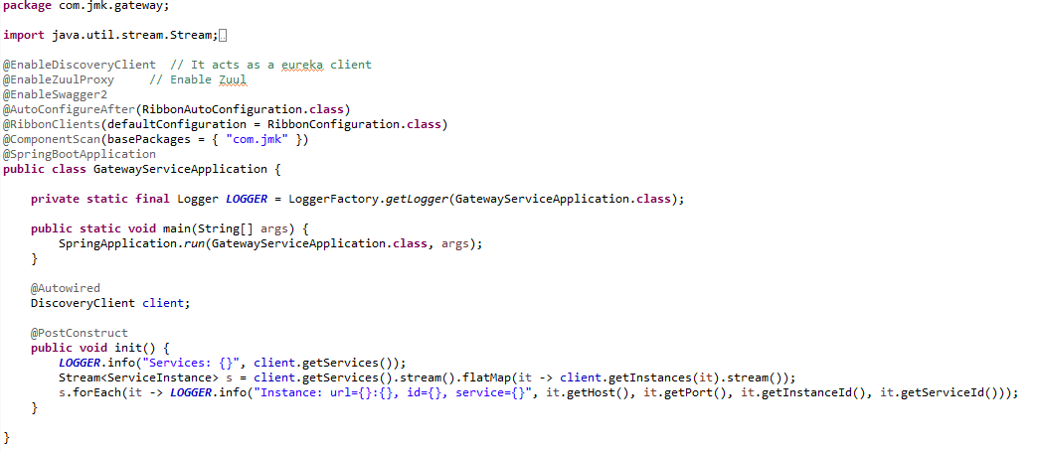

* Need to make changes in this gateway-service application to enable authenticate the user before routing to other microservices.

Can refer the Authentication Service to know about the other changes mentioned below done in this gateway-service



* We use Spring Cloud Netflix Zuul, which is integrated with Kubernetes discovery via Ribbon client. It is exposing Swagger documentation for all our sample microservices distributed across multiple namespaces. The configuration of routes is pretty simple. We just need to use the Spring Cloud Kubernetes discovery feature. In application-prod.properties, please specify the following property.

spring.cloud.kubernetes.discovery.all-namespaces:"true"

While Zuul proxy is automatically integrated with DiscoveryClient we may easily configure dynamic resolution Swagger endpoints exposed by microservices. we may start testing our applications using the Swagger UI exposed on the gateway. But here, we get an unexpected surprise.

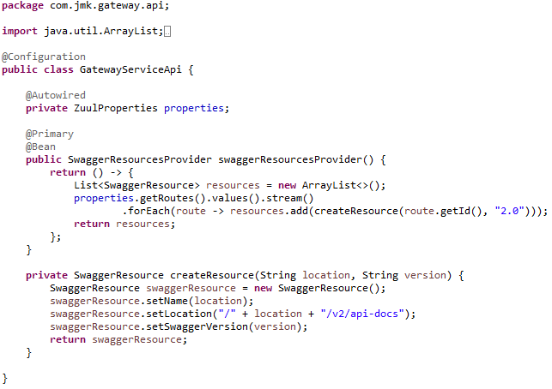

* If we get an unexpected surprise… The discovery across all namespaces does not work for the Ribbon client. It only works for DiscoveryClient. I think that Ribbon auto-configuration should respect the property spring.cloud.kubernetes.discovery.all-namespaces, but in that case, we don’t have any other choice than prepare a workaround. Our workaround is to override Ribbon client auto-configuration provided within Spring Cloud Kubernetes. We are using DiscoveryClient directly for it as shown below.

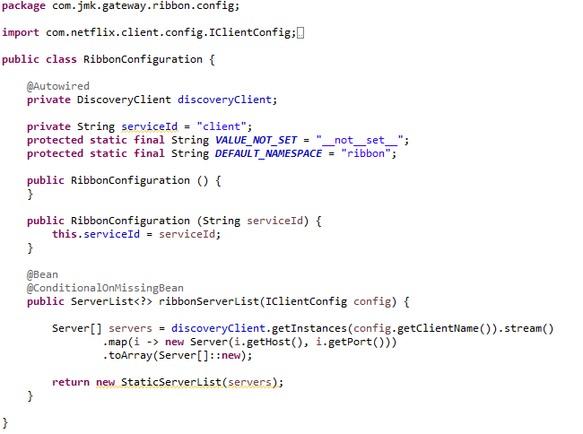

## Testing

### Run in Dev Environment

* Run the application as **Spring Boot App** in the following order
  + EurekaServerApplication
  + GatewayServiceApplication



* Open the browser of Eureka Server at localhost:8761, you should see the running zuul-gateway microservices and enter the url: <http://localhost:8761/>



### Run in Kubernetes Environment

* Running the application in Kubernetes Environment

Following are the steps to run the application in the Kubernetes:

* 1. Create the docker image for the application jar file and pushed into the docker hub using the below command:

**Command**: mvn clean install -DskipTests -Pprod jib:build

* 1. Create the folder k8s which contains the following files:
     + namespace.yaml (Located in main K8s folder: bjjd-microservices\k8s\namespace.yaml)
     + deployment.yaml (Located in application’s K8s folder: bjjd-microservices\user-service\k8s\deployment.yaml)
     + kustomization.yaml (Located in application’s K8s folder: bjjd-microservices\user-service\k8s\kustomization.yaml)
  2. Connect to the kubernetes cluster
* **Command**: gcloud container clusters get-credentials jmk-cluster --zone us-central1-c --project logical-lock-315311
* **Output**
  1. Run the command to create the namespace: bjjd-system in the kubernetes environment:
     + **File:** Namespace.yaml

apiVersion: v1

kind: Namespace

metadata:

name: bjjd-system

* + - **Command**: kubectl apply -f namespace.yaml
    - **Output**:



* 1. Create the kustomization file will be the central point of your base and it describes the resources you use. For example, configmaps, secrets, and it can refer to the resources file: deployment.yaml which is to create the deployment and service in the kubernetes.
* **File**: kustomization.yaml

apiVersion: kustomize.config.k8s.io/v1beta1

kind: Kustomization

namespace: bjjd-system

configMapGenerator:

- name: gateway-service-configmap

literals:

- application.port=1379

- spring.active.profile=prod

resources: #Adding the following yaml resources

- deployment.yaml

* + - **File**: deployment.yaml : to create the deployment and service in the kubernetes

apiVersion: apps/v1

kind: Deployment

metadata:

name: gateway-service

labels:

app: gateway-service

#namespace: default

spec:

replicas: 1

minReadySeconds: 45

selector:

matchLabels:

app: gateway-service

strategy:

rollingUpdate:

maxSurge: 25%

maxUnavailable: 25%

type: RollingUpdate

template:

metadata:

labels:

app: gateway-service

spec:

containers:

- name: gateway-service

image: rajivbansal2981/gateway-service:0.0.1-RELEASE

imagePullPolicy: IfNotPresent #IfNotPresent or Always

ports:

- name: http

containerPort: 1379 # The port that the container exposes

env:

- name: SPRING_ACTIVE_PROFILE

valueFrom:

configMapKeyRef:

name: gateway-service-configmap

key: spring.active.profile

restartPolicy: Always

terminationGracePeriodSeconds: 60

---

apiVersion: v1

kind: Service

metadata:

name: gateway-service

labels: #PODS

app: gateway-service

namespace: default

spec:

type: NodePort #NodePort or LoadBalancer or ClusterIP

selector:

app: gateway-service

ports:

- name: http

port: 1379

targetPort: 1379

* + - Command: kubectl apply -k ./
    - Output:

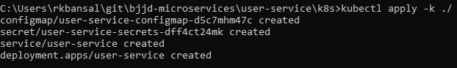

* 1. To check all the application running successfully.
* **Command**: kubectl get pods --namespace bjjd-system -o wide
* **Output**:
  1. If we do not specify in the service type, then by default, Cluster IP Service created which is only accessible from within the cluster.

NOTE: This is the Rest API which ideally we should exposed as Cluster IP only as it will be accessed through API Gateway (Single Entry Point) only.

* + - Command: kubectl get services --namespace bjjd-system -o wide
    - Output:



* 1. To access the user-service from outside the cluster, there are two ways: NodePort and LoadBalancer
     + Nodeport: Used to expose a service on the same port across all the nodes of a cluster. An internal routing mechanism ensures that the request is forwarded to the appropriate pods on each node. This is typically used for services with external consumers.
     + If we define service as Nodeport in the deployment.yaml

apiVersion: v1

kind: Service

metadata:

name: user-service

labels: #PODS

app: user-service

spec:

type: **NodePort** #NodePort or LoadBalancer or ClusterIP

selector:

app: user-service

ports:

- name: hazelcast

port: 5701

- name: app

port: 3379

* + - Run the following commands to access the user-service from outside:
      * **Apply the changes of deployment.yaml file**
        1. **Command**: kubectl apply -k ./
        2. **Output**:

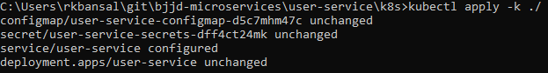

* + - * To check the services again:
        1. Command: kubectl get services --namespace bjjd-system -o wide
        2. Output:
      * To create the firewall rule for the Node’s TCP port:
        1. Command: gcloud compute firewall-rules create bjjd-node-port --project logical-lock-315311 --allow tcp:31924

Name: bjjd-node-port

Project Id: project logical-lock-315311

Allowed TCP Port: 31924

* + - * 1. Output
      * To access the user-service outside the kubernetes using Node’s TCP port:
        + To get the pod details to find the associated Node

Command: kubectl get pods --namespace bjjd-system -o wide

Output:



* + - * To get the Node IP Address

Command: kubectl get pods --namespace bjjd-system -o wide

Output



Node IP with TCP Port

34.134.28.100:31924

* + - * To get the user details using postman

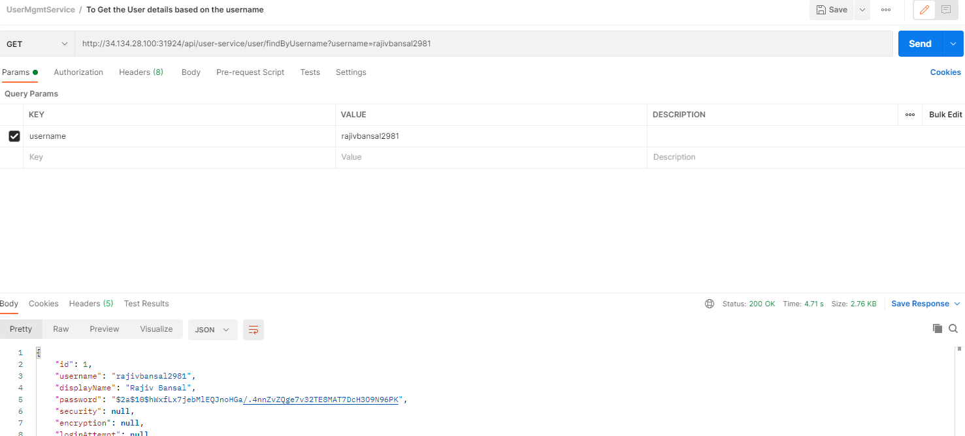

* 1. To access the user-service from outside the cluster, using LoadBalancer IP Service
     + If we define service as Nodeport in the deployment.yaml

apiVersion: v1

kind: Service

metadata:

name: user-service

labels: #PODS

app: user-service

spec:

type: LoadBalancer #NodePort or LoadBalancer or ClusterIP

selector:

app: user-service

ports:

- name: hazelcast

port: 5701

- name: app

port: 3379

* + - Run the following commands to access the user-service from outside:
      * **Apply the changes of deployment.yaml file**
        1. **Command**: kubectl apply -k ./
        2. **Output**:

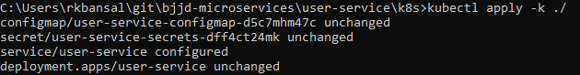

* + - * To check the services again:
        1. Command: kubectl get services --namespace bjjd-system -o wide
        2. Output:



* + - * To get the user details using postman

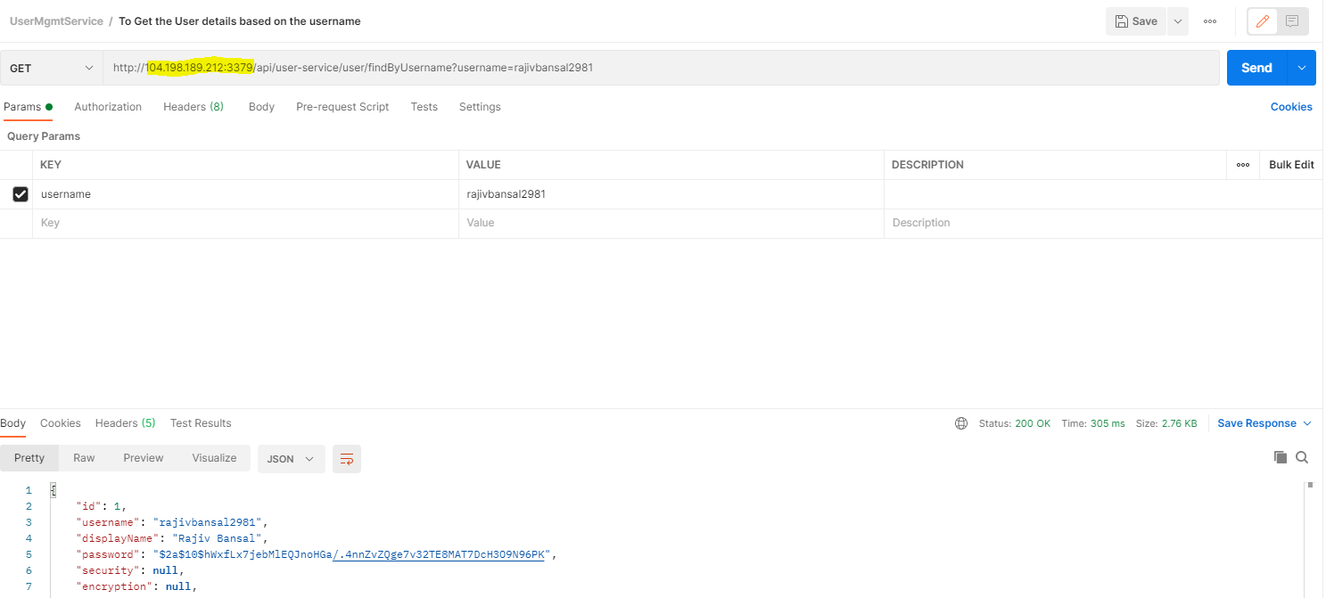

# User Service

## Description

User Service is developed to manage the user profile and its role and authorized module can be accessed by user. User details can be cached for retrieval using Hazelcast Cache. It will have the following functions.

* Create the user:

Other microservices such as people-service will call dependent microservice: **user-service** to create the user credentials/information for every member so that member would be able to login into the BJJD application with his details)

* Update the user
* Get the list of all the user
* Delete the user
* Get the user details
* Find the user details based on the username (which can be used by auth-service).

## Entity Relationship Diagram

## Class Diagram

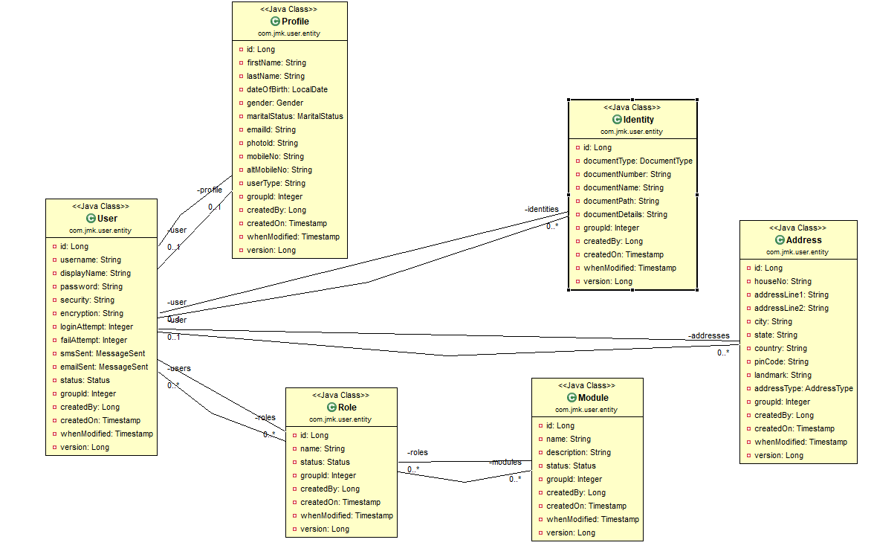

## Use Case Diagram

A use case diagram is a representation of user’s interaction with the system that shows the relationship between the user and the different use cases in which user is involved.

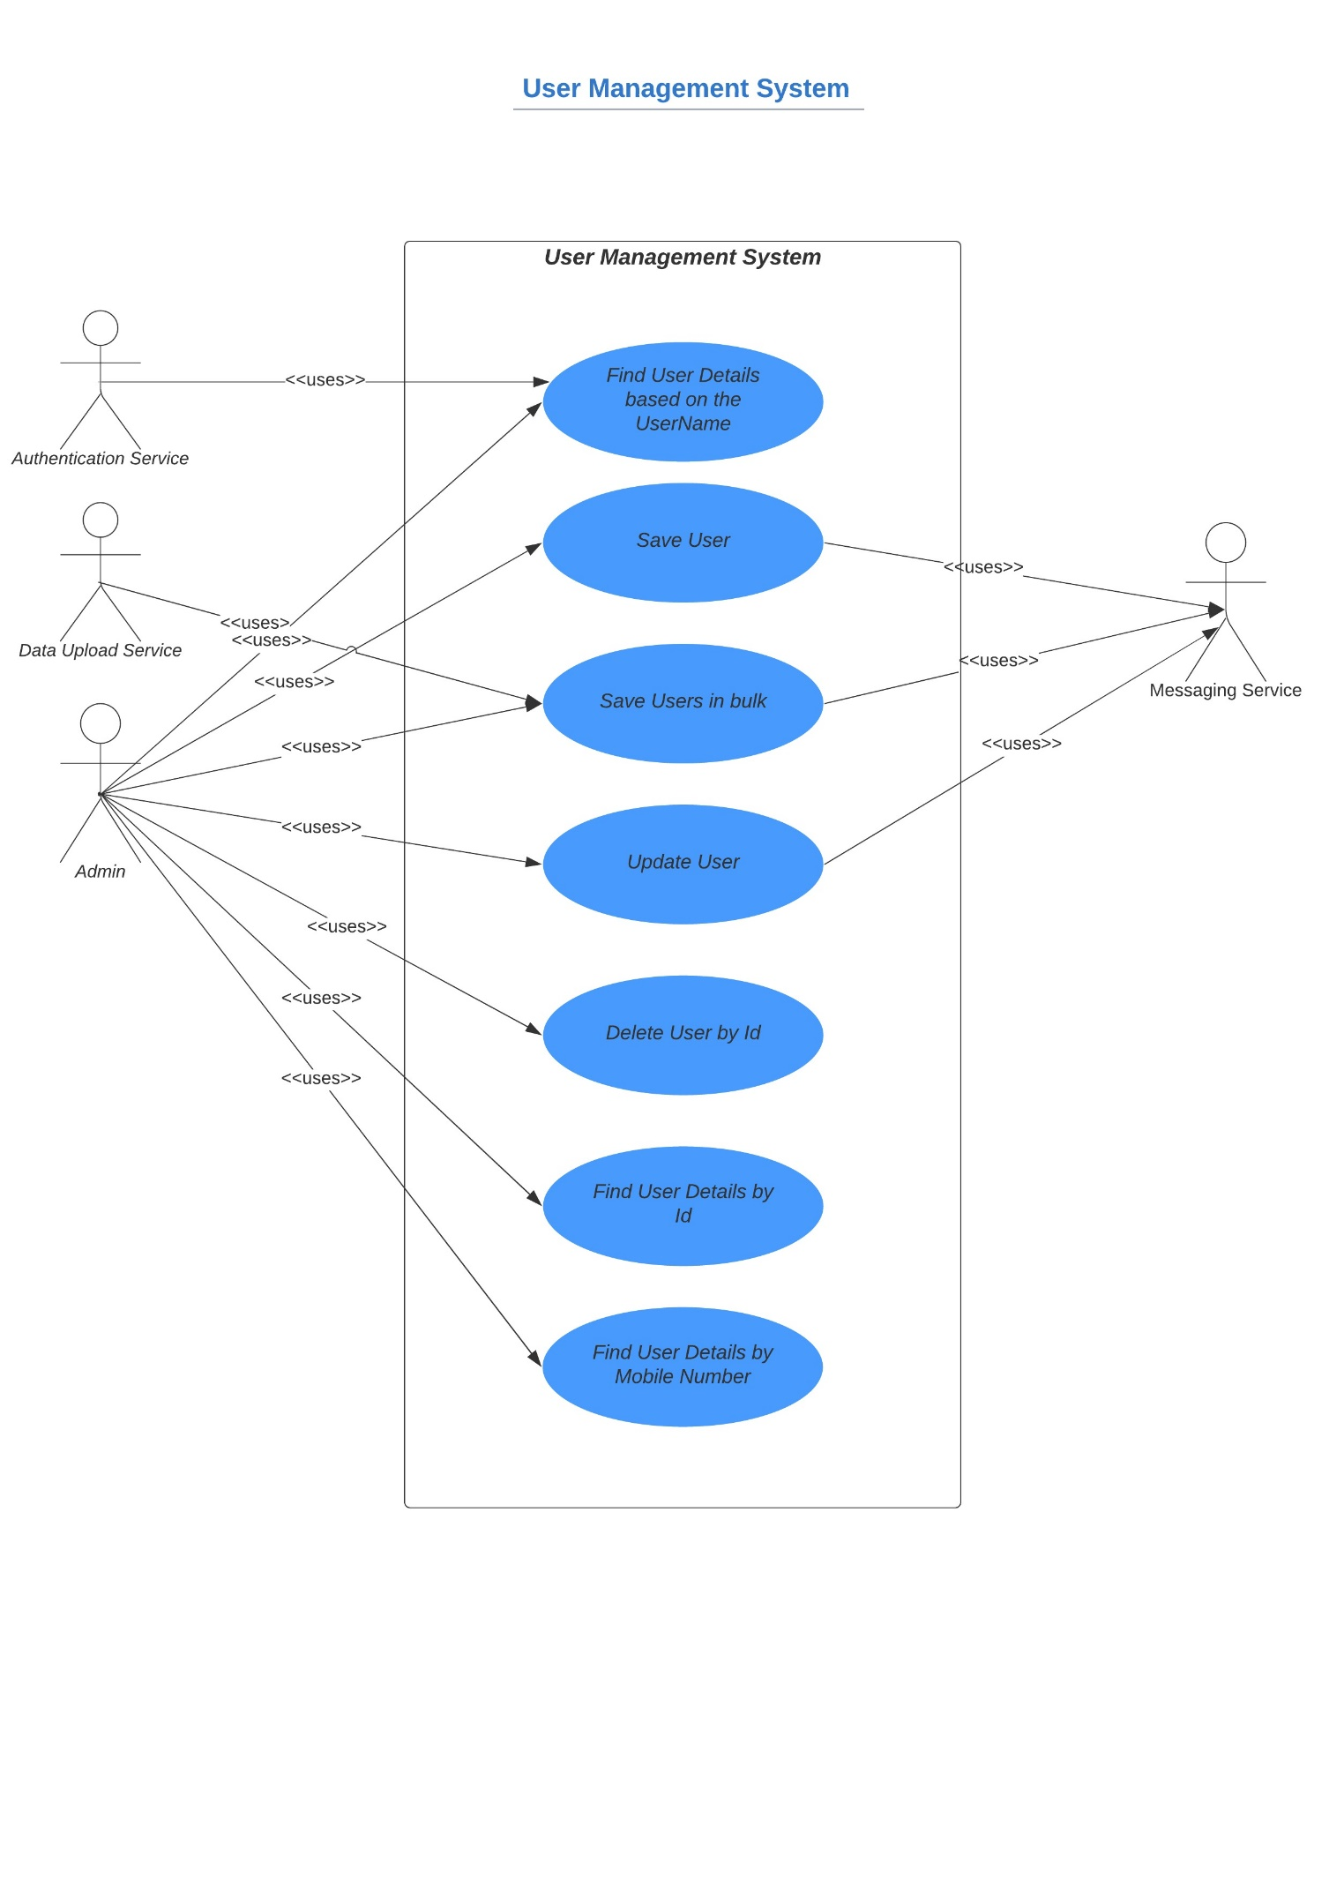

## Use Case Implementation

### Coding

1. Follow the document to implement user-service: **DemoProjectWork-member-mgmt-service.doc** along with the following changes:

|  |  |
| --- | --- |
| Database/Schema Name | users_db |
| User name | bjjd |
| Password | bjjd_379 |

**Commands:**

Connect with the root with the following credentials in MySQL database command line or UI

User Id: root

Password: bjjd

* create database users_db;
* create user 'bjjd'@'%' identified by 'bjjd_379';
* grant all on users_db.* to 'bjjd'@'%';
* grant SELECT,INSERT,UPDATE,DELETE,CREATE,index,drop,ALTER,create temporary tables,references ON users_db.* to 'bjjd'@'%';

1. Use the following document related to the swagger, database scripts, ER diagram of Users:



* mvn --encrypt-master-password rajiv379
* Add the following dependencies in the pom.xml with the following considerations:
  + bjjd-microservices Parent: It contains common dependencies of Spring Boot, Spring Cloud and kubeternetes etc.
  + Common-service: It will keep all the dto models, exception handling and common configurations.
  + Hazelcast: to be used for distributed embedded cache
  + Sql-connector: to connect with the MySQL database.
  + jib-maven-plugin: A Maven plugin for building docker container images for your Java applications and pushed to the docker hub.

<project xmlns=*"http://maven.apache.org/POM/4.0.0"*

xmlns:xsi=*"http://www.w3.org/2001/XMLSchema-instance"*

xsi:schemaLocation=*"http://maven.apache.org/POM/4.0.0 http://maven.apache.org/maven-v4_0_0.xsd"*>

<modelVersion>4.0.0</modelVersion>

<parent>

<groupId>com.jmk</groupId>

<artifactId>bjjd-microservices</artifactId>

<version>0.0.1-RELEASE</version>

</parent>

<artifactId>user-service</artifactId>

<packaging>jar</packaging>

<name>user-service</name>

<description>User Service</description>

<dependencies>

<!-- Cache dependencies -->

<dependency>

<groupId>com.hazelcast</groupId>

<artifactId>hazelcast</artifactId>

<version>4.1</version>

</dependency>

<dependency>

<groupId>com.hazelcast</groupId>

<artifactId>hazelcast-spring</artifactId>

<version>4.1</version>

</dependency>

<!-- https://mvnrepository.com/artifact/com.hazelcast/hazelcast-kubernetes -->

<dependency>

<groupId>com.hazelcast</groupId>

<artifactId>hazelcast-kubernetes</artifactId>

<version>2.2.2</version>

</dependency>

<!-- Starter for using Spring Data JPA with Hibernate -->

<dependency>

<groupId>org.springframework.boot</groupId>

<artifactId>spring-boot-starter-data-jpa</artifactId>

</dependency>

<dependency>

<groupId>mysql</groupId>

<artifactId>mysql-connector-java</artifactId>

<version>8.0.25</version><!--$NO-MVN-MAN-VER$ -->

</dependency>

<dependency>

<groupId>javax.validation</groupId>

<artifactId>validation-api</artifactId>

</dependency>

<!-- Internal API Dependency -->

<dependency>

<groupId>com.jmk</groupId>

<artifactId>common-service</artifactId>

<version>${jmk-version}</version>

</dependency>

</dependencies>

<build>

<plugins>

<plugin>

<groupId>com.google.cloud.tools</groupId>

<artifactId>jib-maven-plugin</artifactId>

<version>${jib-maven-plugin.version}</version>

<configuration>

<to>

<image>registry.hub.docker.com/rajivbansal2981/user-service:0.0.1-RELEASE</image>

<auth>

<username>rajivbansal2981</username>

<password>rajiv379</password>

</auth>

</to>

</configuration>

</plugin>

</plugins>

</build>

</project>

* Main application.properties file which can further refer the following based on the selected maven profile.
  1. application-dev.properties
  2. application-prod.properties
* application.properties : @spring.profiles.active@ determines which properties file will be referred based on the maven profile: dev or prod

There will be an application.properties file but it will have the following minimum details:

* + - Name of the application
    - Active Default Profile
    - Cloud Config server URI with port

#Name of the application

spring.application.name=user-service

#Active Profile - will relate to development properties file in the server. If this property is absent

#Then, default profile will be activated which is the property file without any environment name at the end.

spring.profiles.active=@spring.profiles.active@

#Setting cloud config server uri with port

spring.cloud.config.uri=http://localhost:8888

* application-dev.properties moved to the git repository: **bjjd-config-server-git-repo** and will be selected if maven profile is dev

#Name to the application

spring.application.name=user-service

#Port of the application

server.port=3379

#It is worth mentioning that user-service acts as a Eureka client. So, we give it a name, port, and link to Eureka server

# eureka server url

eureka.client.service-url.default-zone=http://localhost:8761/eureka

#To disable the Kubernetes Discovery client

spring.cloud.kubernetes.enabled=false

spring.cloud.kubernetes.discovery.include-not-ready-addresses=true

server.servlet.context-path=/api/user-service

spring.jackson.date-format=com.jmk.user.swagger.RFC3339DateFormat

spring.jackson.serialization.WRITE_DATES_AS_TIMESTAMPS=false

#Define properties related to JPA

spring.jpa.hibernate.ddl-auto=create

spring.datasource.url=jdbc:mysql://localhost:3306/users_db

spring.datasource.username=bjjd

spring.datasource.password=bjjd_379

#Optional

spring.datasource.tomcat.max-wait=20000

spring.datasource.tomcat.max-active=50

spring.datasource.tomcat.max-idle=20

spring.datasource.tomcat.min-idle=15

#Below line is commented as it takes by default: org.hibernate.dialect.MySQL5Dialect

#spring.jpa.properties.hibernate.dialect = org.hibernate.dialect.MySQL5Dialect

spring.jpa.properties.hibernate.id.new_generator_mappings = false

spring.jpa.properties.hibernate.format_sql = true

logging.level.org.hibernate.SQL=DEBUG

logging.level.org.hibernate.type.descriptor.sql.BasicBinder=TRACE

* application-prod.properties: It will be selected if maven profile is prod.
  1. Eureka Clients registrations with Eureka server need to be disabled in Kubernetes.
  2. Add client option to your mysql-connector allowPublicKeyRetrieval=true to allow the client to automatically request the public key from the server. Note that AllowPublicKeyRetrieval=True could allow a malicious proxy to perform a MITM attack to get the plaintext password, so it is False by default and must be explicitly enabled.
  3. Adding useSSL=false when you use it for testing/develop purposes

#Name of the application

spring.application.name=user-service

#Port of the application

server.port=3379

#Spring profile

spring.profiles.active=${SPRING_ACTIVE_PROFILE:prod}

spring.cloud.kubernetes.discovery.all-namespaces=true

#It is worth mentioning that user-service acts as a Eureka client. So, we give it a name, port, and link to Eureka server

# eureka server url

#eureka.client.service-url.default-zone=http://localhost:8761/eureka

eureka.client.enabled=false

eureka.client.serviceUrl.registerWithEureka=false

server.servlet.context-path=/api/user-service

spring.jackson.date-format=com.jmk.user.swagger.RFC3339DateFormat

spring.jackson.serialization.WRITE_DATES_AS_TIMESTAMPS=false

#Define properties related to JPA

spring.jpa.hibernate.ddl-auto=validate

spring.datasource.url=jdbc:mysql://${DB_HOSTNAME:localhost}:${DB_PORT:3306}/${DB_NAME:users_db}?allowPublicKeyRetrieval=true&useSSL=false

spring.datasource.username=${DB_USERNAME:bjjd}

spring.datasource.password=${DB_PASSWORD:bjjd_379}

#Optional

spring.datasource.tomcat.max-wait=20000

spring.datasource.tomcat.max-active=50

spring.datasource.tomcat.max-idle=20

spring.datasource.tomcat.min-idle=15

#Below line is commented as it takes by default: org.hibernate.dialect.MySQL5Dialect

spring.jpa.properties.hibernate.dialect = org.hibernate.dialect.MySQL5Dialect

spring.jpa.properties.hibernate.id.new_generator_mappings = false

spring.jpa.properties.hibernate.format_sql = true

logging.level.org.hibernate.SQL=DEBUG

logging.level.org.hibernate.type.descriptor.sql.BasicBinder=TRACE

1. Rename the package of io.swagger to com.jmk.user
2. Rename and refactor the Swagger2SpringBoot.java to UserServiceApplication.java with the following details:
   1. Enable Discovery Client so that it can register with Eureka Server and it supports Kubernetes Discovery System.
   2. Enable JpaRepositories

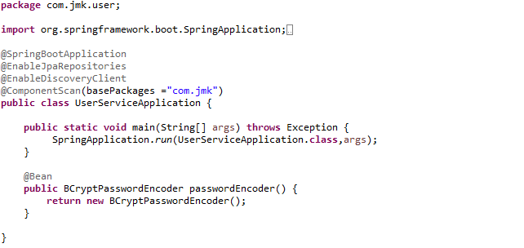

1. Rest UserApi with its implementation

UserApi.java

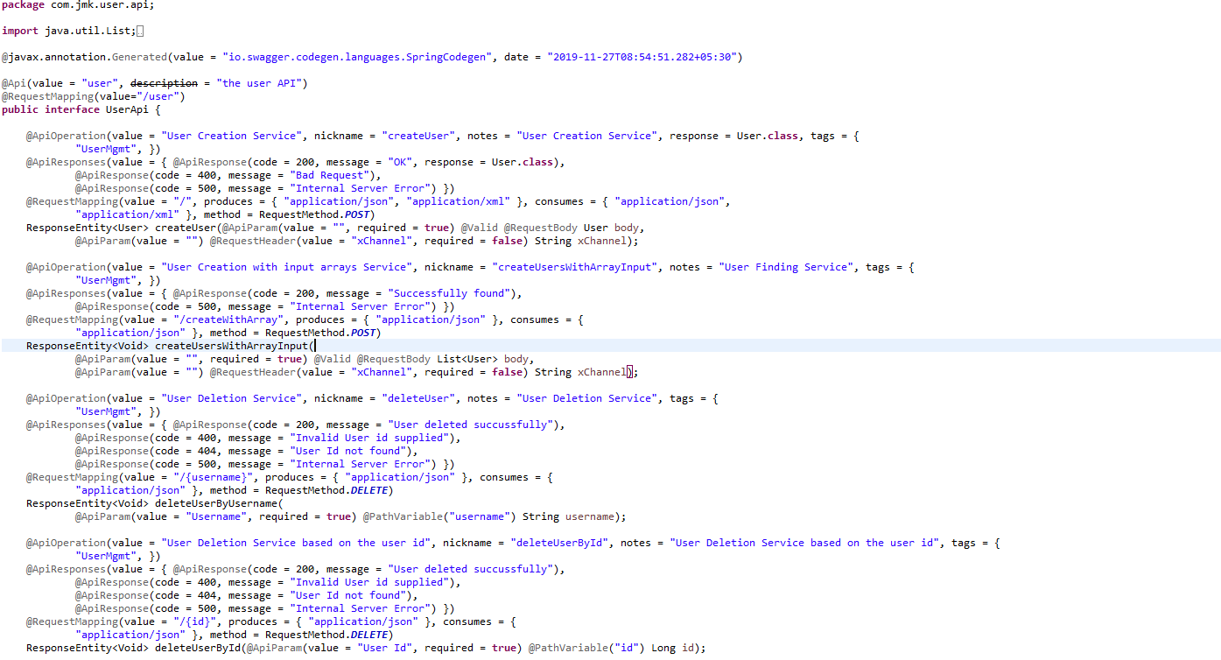

UserApiController.java

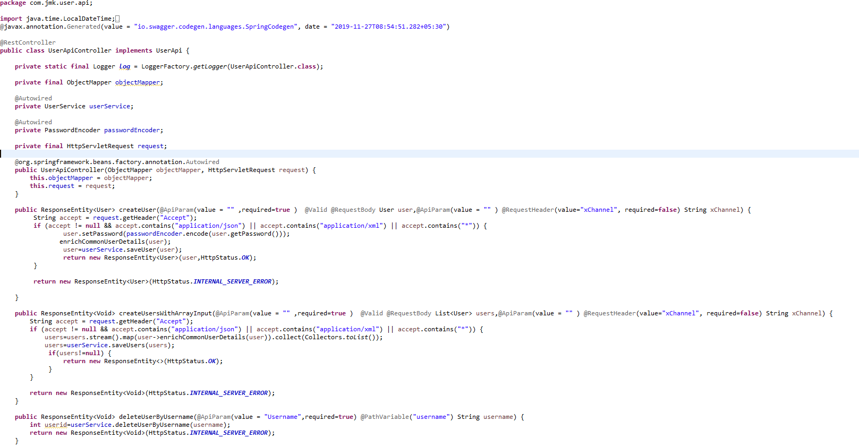

1. Configure the Hazelcast Cache (Embedded Distributed Cache)

* Configure the Hazelcast Cache in the two ways:
  1. If application is running in the Dev environment

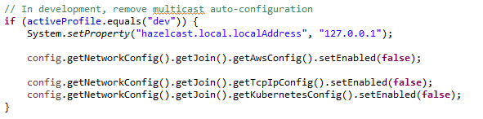

* 1. If application is running in the Kubernetes Environment (Prod)

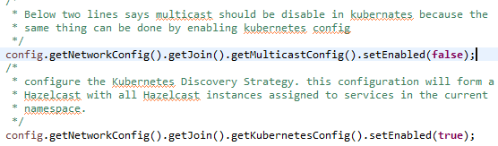

* HazelcastCacheConfiguration.java file to configure the Hazelcast Cache.

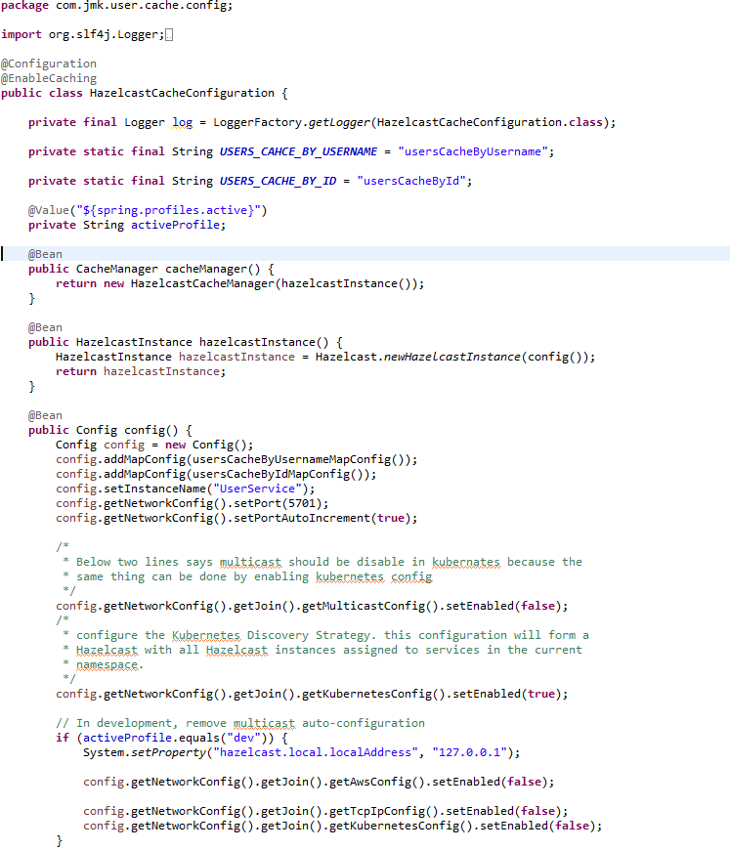

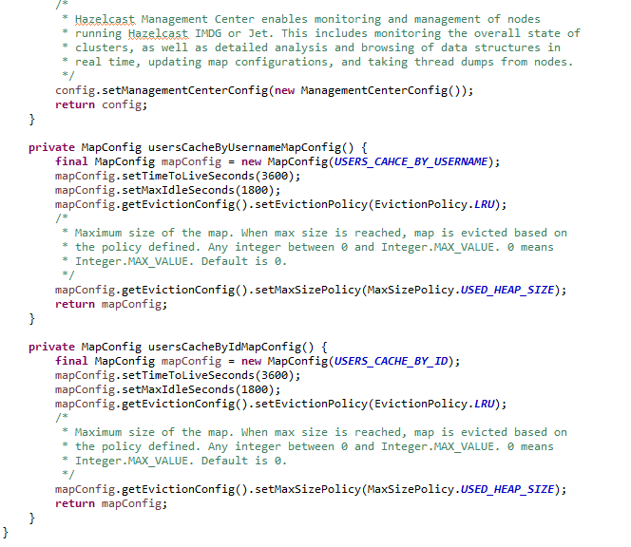

1. User Service should be exposed as following:

**public** **interface** UserService {

User saveUser(User user);

**void** deleteUserById(Long id);

User findUserDetailsByUserName(String userName);

User findUserDetailsById(Long id);

**int** deleteUserByUsername(String username);

List<User> saveUsers(List<User> users);

List<User> findAllUsers();

}

1. User Service Implementation should be exposed as following:
   1. Custom Exception Handling where EntityNotFoundException class (created in common-service) thrown if entity not present in database which is handled in RestExcceptionHandler(created in common-service), in this handler we are creating the appropriate error message in json and send back to client.
   2. Implementations of Hazelcast Cache.

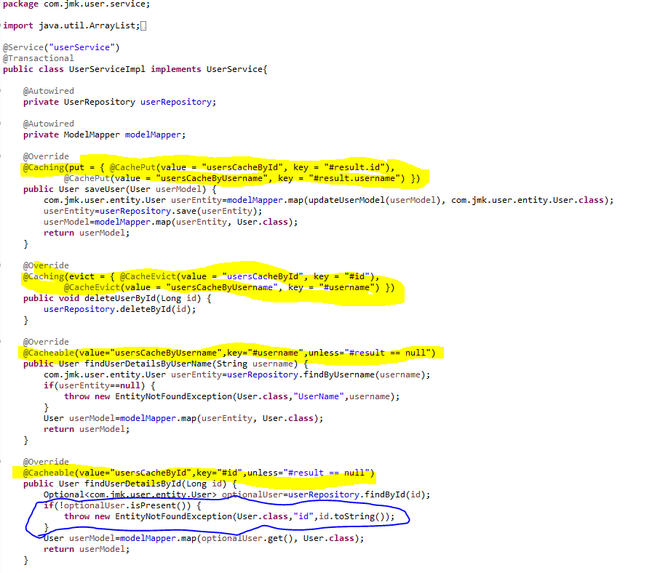

1. UserRepository.java

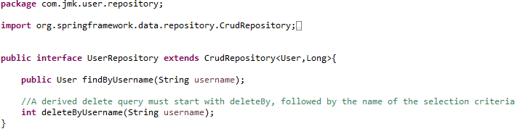

1. Create the model and entities using Lombok.

@**JsonProperty** is suitable for conversion during **serialization**.

@**ApiModelProperty** is **used** for interface document display.

**@Data //It is combination of @ToString, @EqualsAndHashCode ,@Getter,@Setter and @RequiredArgsConstructor**

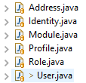

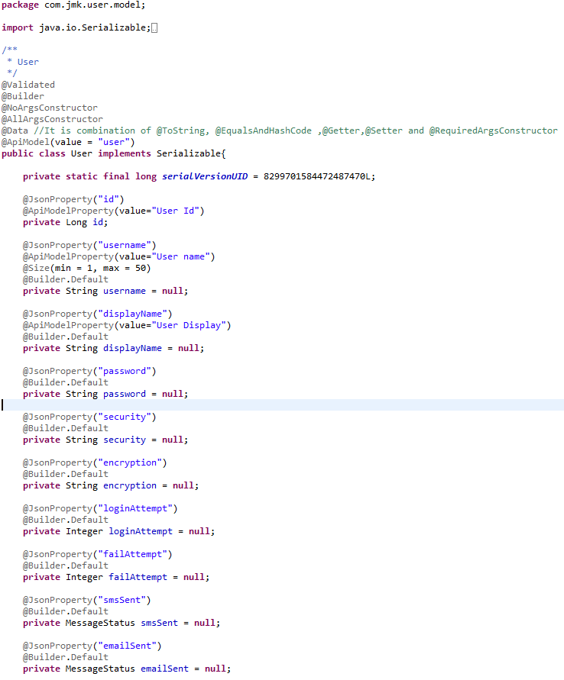

1. Made changes for swagger documentation
   1. in the SwaggerDocumentationConfig, @EnableSwagger2 - Annotation to Enable Swagger Documentation on the API

@EnableSwagger2

@Configuration

**public** **class** SwaggerDocumentationConfig {

ApiInfo apiInfo() {

**return** **new** ApiInfoBuilder()

.title("User Managerment Service API")

.description("User Managerment Service API for BJJD")

.license("")

.licenseUrl("http://unlicense.org")

.termsOfServiceUrl("")

.version("18.10.0")

.contact(**new** Contact("","", ""))

.build();

}

@Bean

**public** Docket customImplementation(){

**return** **new** Docket(DocumentationType.***SWAGGER_2***)

.select()

.apis(RequestHandlerSelectors.*basePackage*("com.jmk.user.api")).paths(PathSelectors.*regex*("/user.*"))

.build()

.directModelSubstitute(org.threeten.bp.LocalDate.**class**, java.sql.Date.**class**)

.directModelSubstitute(org.threeten.bp.OffsetDateTime.**class**, java.util.Date.**class**)

.apiInfo(apiInfo());

}

}

* 1. Made changes in the Swagger’s HomeController



1. Run the application as **Spring Boot App** in the following order
   1. EurekaServerApplication
   2. UserMgmtRestApplication

Check Eureka Server is running and UserMgmtServiceApplication is registered with Eureka Server: <http://localhost:8761/>



1. After running the application, should be visible following functions for the following url: <http://localhost:3379/api/user-mgmt-service/swagger-ui.html>

Or

<http://localhost:3379/api/user-mgmt-service/api-docs>



### Testing

#### Junit Testing

Test the User Api using JUnit



#### Testing in Dev Environment

* Getting user details based on the username using Postman



* Getting user details based on the username but not found, then custom ApiError message will be shown using Postman



#### Testing in Kubernetes Environment

* Running the application in Kubernetes Environment

Following are the steps to run the application in the Kubernetes:

* 1. Create the docker image for the application jar file and pushed into the docker hub using the below command:

**Command**: mvn clean install -DskipTests -Pprod jib:build

* 1. Create the folder k8s which contains the following files:
     + namespace.yaml (Located in main K8s folder: bjjd-microservices\k8s\namespace.yaml)
     + rbac.yaml (Located in main K8s folder: bjjd-microservices\k8s\rbac.yaml)
     + deployment.yaml (Located in application’s K8s folder: bjjd-microservices\user-service\k8s\deployment.yaml)
     + kustomization.yaml (Located in application’s K8s folder: bjjd-microservices\user-service\k8s\kustomization.yaml)
  2. Connect to the kubernetes cluster
* **Command**: gcloud container clusters get-credentials jmk-cluster --zone us-central1-c --project logical-lock-315311
* **Output**
  1. Run the command to create the namespace: bjjd-system in the kubernetes environment:
     + **File:** Namespace.yaml

apiVersion: v1

kind: Namespace

metadata:

name: bjjd-system

* + - **Command**: kubectl apply -f namespace.yaml
    - **Output**:



* 1. Run the following command as we are using Hazelcast cache in this microservices. Hazelcast uses Kubernetes API for auto-discovery. That is why you need to grant certain roles to your service account. we can do it by creating the following “rbac.yaml” file.
     + **File**: rbac.yaml

apiVersion: rbac.authorization.k8s.io/v1

kind: ClusterRoleBinding

metadata:

name: default-cluster

roleRef:

apiGroup: rbac.authorization.k8s.io

kind: ClusterRole

name: view

subjects:

- kind: ServiceAccount

name: default

namespace: bjjd-system

* + - **Command**: kubectl apply -f rbac.yaml
    - **Output**



* 1. Create the kustomization file will be the central point of your base and it describes the resources you use. For example, configmaps, secrets, and it can refer to the resources file: deployment.yaml which is to create the deployment and service in the kubernetes.
* **File**: kustomization.yaml

apiVersion: kustomize.config.k8s.io/v1beta1

kind: Kustomization

namespace: bjjd-system

configMapGenerator:

- name: user-service-configmap

literals:

- database.hostname=db-server.cznoz9bpqnlj.ap-south-1.rds.amazonaws.com

- database.name=users_db

- database.port=3306

- database.username=bjjd

- application.port=3379

- hazelcast.port=5701

- spring.active.profile=prod

secretGenerator:

- name: user-service-secrets

literals:

- database.root.password=server_42_123 #My sql root password:bjjd

- database.password=bjjd_379

resources: #Adding the following yaml resources

- deployment.yaml

* + - **File**: deployment.yaml : to create the deployment and service in the kubernetes

apiVersion: apps/v1

kind: Deployment

metadata:

name: user-service

labels:

app: user-service

spec:

replicas: 1

minReadySeconds: 45

selector:

matchLabels:

app: user-service

strategy:

rollingUpdate:

maxSurge: 25%

maxUnavailable: 25%

type: RollingUpdate

template:

metadata:

labels:

app: user-service

spec:

containers:

- name: user-service

image: rajivbansal2981/user-service:0.0.1-RELEASE

imagePullPolicy: Always #IfNotPresent

ports:

- name: http

containerPort: 3379 # The port that the container exposes

- name: multicast

containerPort: 5701 # The port that Hazelcast exposes

env:

- name: DB_HOSTNAME

valueFrom:

configMapKeyRef:

name: user-service-configmap

key: database.hostname #MySQL db host name

- name: DB_NAME

valueFrom:

configMapKeyRef:

name: user-service-configmap

key: database.name

- name: DB_USERNAME

valueFrom:

configMapKeyRef:

name: user-service-configmap

key: database.username

- name: DB_PASSWORD

valueFrom:

secretKeyRef:

name: user-service-secrets

key: database.password

- name: DB_PORT

valueFrom:

configMapKeyRef:

name: user-service-configmap

key: database.port

- name: SPRING_ACTIVE_PROFILE

valueFrom:

configMapKeyRef:

name: user-service-configmap

key: spring.active.profile

restartPolicy: Always

terminationGracePeriodSeconds: 60

---

apiVersion: v1

kind: Service

metadata:

name: user-service

labels: #PODS

app: user-service

spec:

type: ClusterIP #NodePort or LoadBalancer or ClusterIP

selector:

app: user-service

ports:

- name: hazelcast

port: 5701

- name: app

port: 3379

* + - Command: kubectl apply -k ./
    - Output:



* 1. To check all the application running successfully.
* **Command**: kubectl get pods --namespace bjjd-system -o wide
* **Output**:
  1. If we do not specify in the service type, then by default, Cluster IP Service created which is only accessible from within the cluster.

NOTE: This is the Rest API which ideally we should exposed as Cluster IP only as it will be accessed through API Gateway (Single Entry Point) only.

* + - Command: kubectl get services --namespace bjjd-system -o wide
    - Output:



* 1. To access the user-service from outside the cluster, there are two ways: NodePort and LoadBalancer
     + Nodeport: Used to expose a service on the same port across all the nodes of a cluster. An internal routing mechanism ensures that the request is forwarded to the appropriate pods on each node. This is typically used for services with external consumers.
     + If we define service as Nodeport in the deployment.yaml

apiVersion: v1

kind: Service

metadata:

name: user-service

labels: #PODS

app: user-service

spec:

type: **NodePort** #NodePort or LoadBalancer or ClusterIP

selector:

app: user-service

ports:

- name: hazelcast

port: 5701

- name: app

port: 3379

* + - Run the following commands to access the user-service from outside:
      * **Apply the changes of deployment.yaml file**
        1. **Command**: kubectl apply -k ./
        2. **Output**:



* + - * To check the services again:
        1. Command: kubectl get services --namespace bjjd-system -o wide
        2. Output:
      * To create the firewall rule for the Node’s TCP port:
        1. Command: gcloud compute firewall-rules create bjjd-node-port --project logical-lock-315311 --allow tcp:31924

Name: bjjd-node-port

Project Id: project logical-lock-315311

Allowed TCP Port: 31924

* + - * 1. Output
      * To access the user-service outside the kubernetes using Node’s TCP port:
        + To get the pod details to find the associated Node

Command: kubectl get pods --namespace bjjd-system -o wide

Output:



* + - * To get the Node IP Address

Command: kubectl get pods --namespace bjjd-system -o wide

Output



Node IP with TCP Port

34.134.28.100:31924

* + - * To get the user details using postman



* 1. To access the user-service from outside the cluster, using LoadBalancer IP Service
     + If we define service as Nodeport in the deployment.yaml

apiVersion: v1

kind: Service

metadata:

name: user-service

labels: #PODS

app: user-service

spec:

type: LoadBalancer #NodePort or LoadBalancer or ClusterIP

selector:

app: user-service

ports:

- name: hazelcast

port: 5701

- name: app

port: 3379

* + - Run the following commands to access the user-service from outside:
      * **Apply the changes of deployment.yaml file**
        1. **Command**: kubectl apply -k ./
        2. **Output**:



* + - * To check the services again:
        1. Command: kubectl get services --namespace bjjd-system -o wide
        2. Output:



* + - * To get the user details using postman



# Authentication Service

## Description

Authentication Service is used for validating user credentials, and issuing tokens.

The authentication flow is simple as:

* 1. The user sends a request to get a token passing his credentials.
  2. The server validates the credentials and sends back a token.
  3. With every request, the user has to provide the token, and server will validate that token.
* Validating the token in Authentication service for every request: Gateway Service has to call the auth service to validate user credentials and the issued token before allowing the requests to go to any service.
* Authentication Service Tools
  1. Spring Cloud Security
  2. OAuth2
  3. JWT
* Authentication service can call any user-mgmt-service to validate the user credentials with the DB or any other source.

We’ll introduce another service called ‘auth service’ for validating user credentials, and issuing tokens.

What about validating the token? Well, it can be implemented in the auth service itself, and the gateway has to call the auth service to validate the token before allowing the requests to go to any service.

Instead, we can validate the tokens at the gateway level, and let the auth service validate user credentials, and issue tokens. And that’s what we’re going to do here.

In both ways, we are blocking the requests unless it’s authenticated (except the requests for generating tokens).

**JSON Based Token (JWT)**

* A token is an encoded string, generated by our application (after being authenticated) and sent by the user along each request to allow access to the resources exposed by our application.
* JSON Based Token (JWT) is a JSON-based open standard for creating access tokens. It consists of three parts; header, payload, and signature.
* The header contains the hashing algorithm

{type: “JWT”, hash: “HS256”}

* The payload contains attributes (username, email, etc) and their values.

{username: "Omar", email: "omar@example.com", admin: true }

* The signature is hashing of: Header + “.” + Payload + Secret key

## Coding

**To implement the Authentication Service there are two major steps :**

1. Need to change in the gateway-service(gateway-zuul) previously created project.
2. Create Authentication Service

**I. Need to change in the gateway-service(gateway-service) previously created project**

In the gateway, we need to do two things:

* 1. validate tokens with every request, and
  2. prevent all unauthenticated requests to our services. Fair enough?

**🡪Steps:**

* In the pom.xml add spring security and JWT dependencies.



* Made changes in the application.properties



* Three Java Classes need to be created
  + SecurityTokenConfig
  + JwtTokenAuthenticationFilter
  + JwtConfig
  + JwtAuthenticationEntryPoint – to handle an authorized attempt
  + CurrentUserAuthenticationFilter
* To define our security configurations, create a class, and annotated with @EnableWebSecurity, and extends WebSecurityConfigurerAdapter class to override and provide our own custom security configurations.

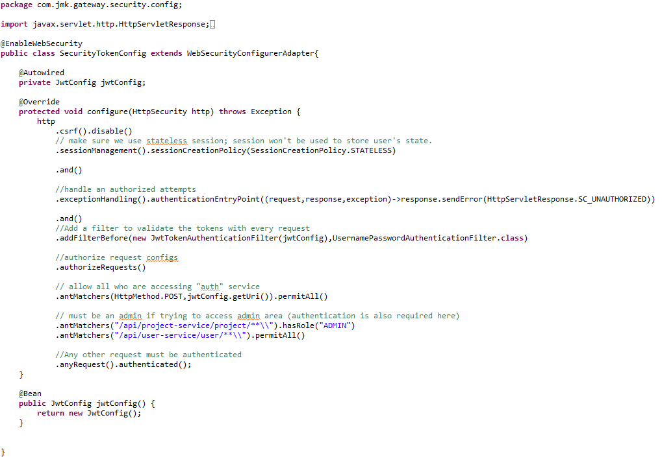

* Create the filter **JwtTokenAuthenticationFilter**

Spring has filters that will get executed within the life cycle of the request (filter chain). To enable and use these filters, we need to extend the class of any of these filters.

By default, spring will try to figure out when the filter should be executed. Otherwise, we can also define when should be executed (after or before another filter).

In this step, we implement our filter that validates the tokens. We’re using OncePerRequestFilter. It guarantee a single execution per request (since you can have a filter on the filter chain more than once).

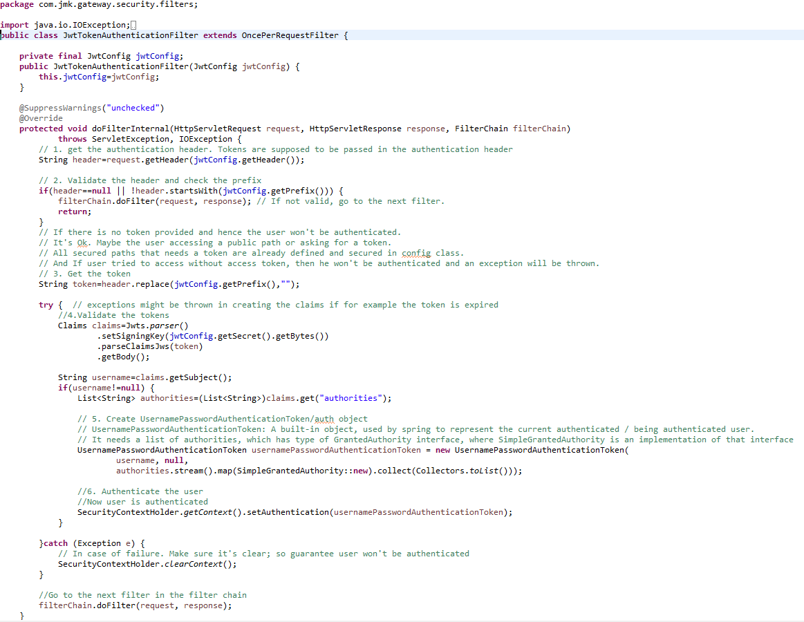

* Create **JwtConfig** Class first which contains configuration variables with getters and setters.



* Create **JwtAuthenticationEntryPoint** to handle the authorized attempt

This class is used to return a 401 unauthorized error to clients that try to access a protected resource without proper authentication. It implements Spring Security's AuthenticationEntryPoint interface.

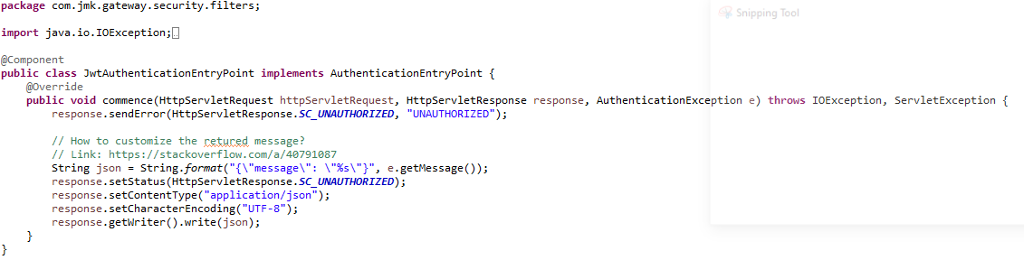

* **Create Current User Authentication Filter**

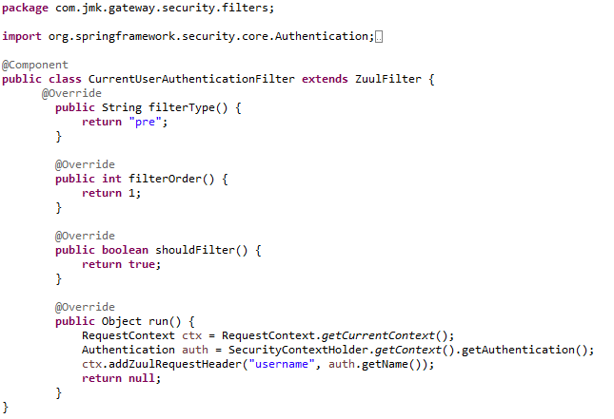

1. **Create Authentication Service**

In the auth service, we need to

* + 1. Validate the user credentials, and if valid: by calling user-service using Feign Client
    2. generate a token, otherwise, throw an exception.

**🡪Steps:**

* Create Spring Boot Project



* Click on next and fill the required details shown in the below screen:



* Add the following dependencies in the pom.xml with the following considerations:
  + bjjd-microservices Parent: It contains common dependencies of Spring Boot, Spring Cloud and kubeternetes etc.
  + Common-service: It will keep all the dto models, exception handling and common configurations.
  + jib-maven-plugin: A Maven plugin for building docker container images for your Java applications and pushed to the docker hub.
  + JWT: Json Web Token

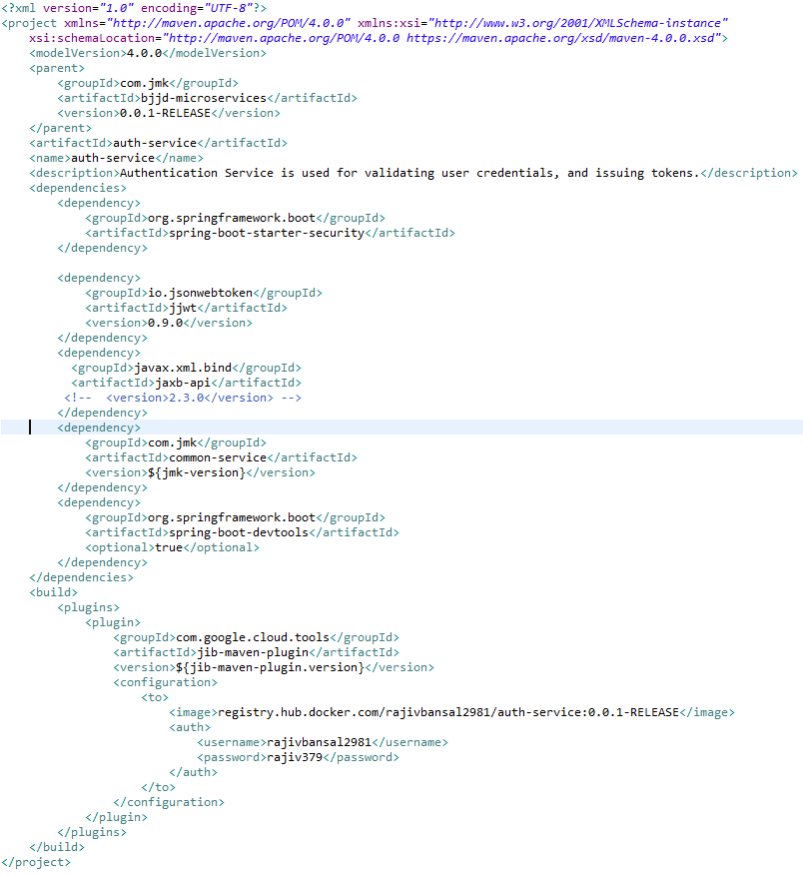

* Main application.properties file which can further refer the following based on the selected maven profile.
  1. application-dev.properties
  2. application-prod.properties
* application.properties : @spring.profiles.active@ determines which properties file will be referred based on the maven profile: dev or prod

There will be an application.properties file but it will have the following minimum details:

* + - Name of the application
    - Active Default Profile
    - Cloud Config server URI with port

#Name of the application

spring.application.name=auth-service

#Active Profile - will relate to development properties file in the server. If this property is absent

#then,default profile will be activated which is the property file without any environment name at the end.

spring.profiles.active=@spring.profiles.active@

#Setting cloud config server uri with port

spring.cloud.config.uri=http://localhost:8888

* application-dev.properties moved to the git repository: **bjjd-config-server-git-repo** and will be selected if maven profile is dev

#Name of the application

spring.application.name=auth-service

#Port of the application

server.port=2379

#It is worth mentioning that user-service acts as a Eureka client. So, we give it a name, port, and link to Eureka server

# eureka server url

eureka.client.service-url.default-zone=http://localhost:8761/eureka

eureka.client.registerWithEureka=true

eureka.client.fetchRegistry=true

#Feign client configuration

feign.client.config.default.connectTimeout: 16000000

feign.client.config.default.readTimeout: 16000000

* application-prod.properties: It will be selected if maven profile is prod.
  1. Eureka Clients registrations with Eureka server need to be disabled in Kubernetes.

#Application Name

spring.application.name=auth-service

#Port of the application

server.port=2379

#Spring profile

spring.profiles.active=${SPRING_ACTIVE_PROFILE:prod}

spring.cloud.kubernetes.discovery.all-namespaces=true

#It is worth mentioning that user-service acts as a Eureka client. So, we give it a name, port, and link to Eureka server

# Eureka server url

#eureka.client.service-url.default-zone=http://localhost:8761/eureka

eureka.client.enabled=false

eureka.client.serviceUrl.registerWithEureka=false

#Feign client configuration

feign.client.config.default.connectTimeout: 16000000

feign.client.config.default.readTimeout: 16000000

#spring.jackson.date-format=com.jmk.user.swagger.RFC3339DateFormat

#spring.jackson.serialization.WRITE_DATES_AS_TIMESTAMPS=false

hystrix.command.default.execution.isolation.thread.timeoutInMilliseconds=5000000

ribbon.ReadTimeout=20000000

ribbon.ConnectTimeout=20000000

* Update the main **AuthServiceApplication** application with the following details:
  + Enable Eureka Client so that it can register with Eureka Server
  + Enable FeignClient to interact with user--service
  + Enable JpaRepositories

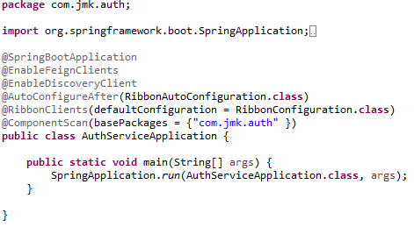

* Following Classes will be created in this class.
  + UserServiceClient.java – Feign Client for user-service
  + UserDetailsServiceImpl.java – It will call microservice: user-service to validate the credentials using feign client created above.
  + SecurityCredentialsConfig.java
  + JwtUsernameAndPasswordAuthenticationFilter.java
  + JwtConfig.java (same as already created in the above section)
  + RibbonConfiguration.java
* UserServiceClient- Feign Client for user-mgmt-service.
* Feign dynamically generates the implementation of the interface we created, so Feign has to know which service to call beforehand. That's why we need to give a name for the interface, which is the {Service-Id} of UserMgmtService. Now, Feign contacts the Eureka server with this Service Id, resolves the actual IP/hostname of the UserMgmtService, and calls the URL provided in Request Mapping.
* To send HTTP Request to a destination **user-mgmt-service** Microservice we will need to create a Feign Client interface. Please note the use of @FeignClient annotation which accepts the name user-mgmt-service under which the destination Microservice is registered with Eureka Discovery Service.

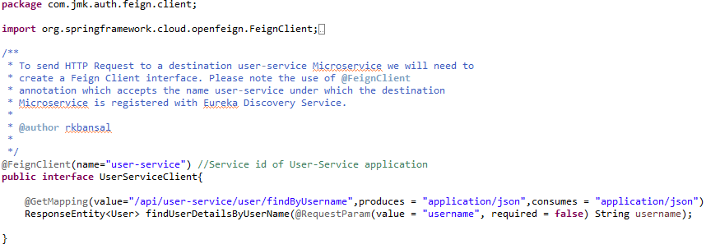

* UserDetailsServiceImpl –

It will implement UserDetailsService(Spring Security API) interface and will call microservice: user-mgmt-service to validate the credentials using feign client created above.

This class acts like a provider for the user; meaning it loads the user from the database (or any data source). It doesn’t do authentication. It just loads the user given his username.

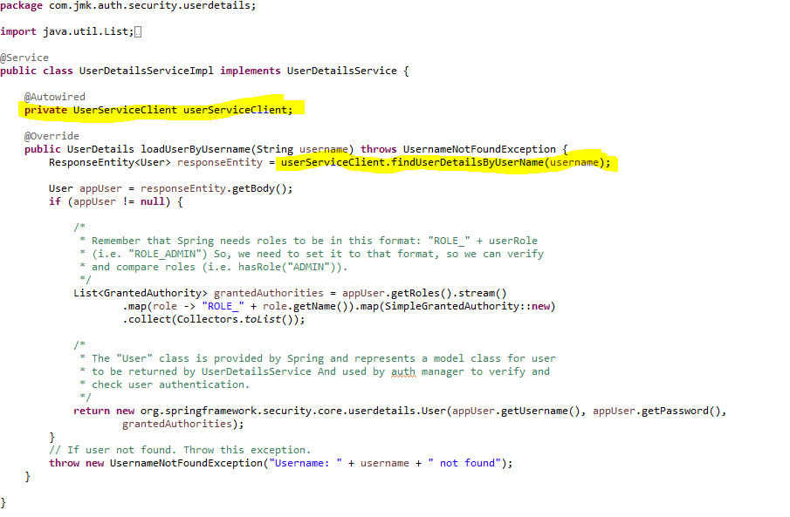

* SecurityCredentialsConfig :

As we did in the Gateway for security configurations, create a class: SecurityCredentialsConfig, annotated with @EnableWebSecurity, and extends WebSecurityConfigurerAdapter



* JwtUsernameAndPasswordAuthenticationFilter

We’re using JwtUsernameAndPasswordAuthenticationFilter. It’s used to validate user credentials, and generate tokens. The username and password must be sent in a POST request.

NOTE: we can complete the following class with getter and setter of UserCredentials not showing in the below pic.



* Create **JwtConfig** Class first which contains configuration variables with getters and setters.



* If we get an unexpected surprise… The discovery across all namespaces does not work for the Ribbon client. It only works for DiscoveryClient. I think that Ribbon auto-configuration should respect the property spring.cloud.kubernetes.discovery.all-namespaces, but in that case we don’t have any other choice than prepare a workaround. Our workaround is to override Ribbon client auto-configuration provided within Spring Cloud Kubernetes. We are using DiscoveryClient directly for it as shown below.

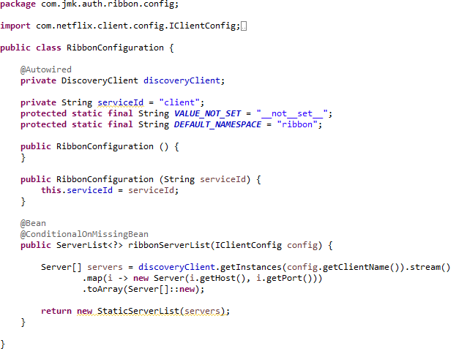

## Testing

### Testing in Dev Environment

* Run the application as **Spring Boot App** in the following order
  1. EurekaServerApplication
  2. UserServiceApplication
  3. AuthServiceApplication
  4. ZuulGatewayApplication
* Open the browser of Eureka Server at localhost:8761, you should see the all the microservices running and enter the url: <http://localhost:8761/>



* To use any microservices, we have to go via zuul-gateway port: 1379.
  + To get the token, user will pass his credentials and call auth service via zuul-gateway service.
  + The Auth service validates the credentials and sends back a token.
  + With every request, the user has to provide the token, and server will validate that token.

**Request**



**Response –** see the response header containing the token in the Authorization attribute.



### Testing in Kubernetes Environment

* Perquisite:
  + Below services should be in running state in Kubernetes
    - Gateway-service: as NodePort or LoadBalancer so that can be accessed any service using this single-entry point.
    - User-service: Authenticate service will use user-service to authenticate the user credentials.

Following are the steps to run the application in the Kubernetes:

* 1. Create the docker image for the application jar file and pushed into the docker hub using the below command:

**Command**: mvn clean install -DskipTests -Pprod jib:build

* 1. Create the folder k8s which contains the following files:
     + namespace.yaml (Located in main K8s folder: bjjd-microservices\k8s\namespace.yaml)
     + deployment.yaml (Located in application’s K8s folder: bjjd-microservices\user-service\k8s\deployment.yaml)
     + kustomization.yaml (Located in application’s K8s folder: bjjd-microservices\user-service\k8s\kustomization.yaml)
  2. Connect to the kubernetes cluster
* **Command**: gcloud container clusters get-credentials jmk-cluster --zone us-central1-c --project logical-lock-315311
* **Output**
  1. Run the command to create the namespace: bjjd-system in the kubernetes environment:
     + **File:** Namespace.yaml

apiVersion: v1

kind: Namespace

metadata:

name: bjjd-system

* + - **Command**: kubectl apply -f namespace.yaml
    - **Output**:



* 1. Create the kustomization file will be the central point of your base and it describes the resources you use. For example, configmaps, secrets, and it can refer to the resources file: deployment.yaml which is to create the deployment and service in the kubernetes.
* **File**: kustomization.yaml

apiVersion: kustomize.config.k8s.io/v1beta1

kind: Kustomization

namespace: bjjd-system

configMapGenerator:

- name: auth-service-configmap

literals:

- application.port=2379

- spring.active.profile=prod

resources: #Adding the following yaml resources

- deployment.yaml

* + - **File**: deployment.yaml : to create the deployment and service in the kubernetes

apiVersion: apps/v1

kind: Deployment

metadata:

name: auth-service

labels:

app: auth-service

#namespace: default

spec:

replicas: 1

minReadySeconds: 45

selector:

matchLabels:

app: auth-service

strategy:

rollingUpdate:

maxSurge: 25%

maxUnavailable: 25%

type: RollingUpdate

template:

metadata:

labels:

app: auth-service

spec:

containers:

- name: auth-service

image: rajivbansal2981/auth-service:0.0.1-RELEASE

imagePullPolicy: Always #IfNotPresent

ports:

- name: http

containerPort: 2379 # The port that the container exposes

env:

- name: SPRING_ACTIVE_PROFILE

valueFrom:

configMapKeyRef:

name: auth-service-configmap

key: spring.active.profile

restartPolicy: Always

terminationGracePeriodSeconds: 60

---

apiVersion: v1

kind: Service

metadata:

name: auth-service

labels: #PODS

app: auth-service

namespace: default

spec:

type: ClusterIP #NodePort or LoadBalancer or ClusterIP

selector:

app: auth-service

ports:

- name: app

port: 2379

* + - Command: kubectl apply -k ./
    - Output:

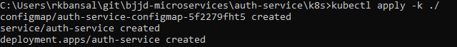

* 1. To check all the application running successfully.
* **Command**: kubectl get pods --namespace bjjd-system -o wide
* **Output**:
  1. If we do not specify in the service type, then by default, Cluster IP Service created which is only accessible from within the cluster.

NOTE: This is the Rest API which ideally we should exposed as Cluster IP only as it will be accessed through API Gateway (Single Entry Point) only.

* + - Command: kubectl get services --namespace bjjd-system -o wide
    - Output:



* 1. To access the auth-service from outside the cluster, we need gateway-service to be in running stage which will be exposed as Nodeport or LoadBalancer.
     + Go To the gateway-service section, and run the gateway-service.
     + After running the gateway-service, check the services are running.
       - To get the Node IP Address

Command: kubectl get pods --namespace bjjd-system -o wide

Output



Node IP with TCP Port

34.134.28.100:31924

* + - * To get the user details using postman



* 1. To access the user-service from outside the cluster, using LoadBalancer IP Service
     + If we define service as Nodeport in the deployment.yaml

apiVersion: v1

kind: Service

metadata:

name: user-service

labels: #PODS

app: user-service

spec:

type: LoadBalancer #NodePort or LoadBalancer or ClusterIP

selector:

app: user-service

ports:

- name: hazelcast

port: 5701

- name: app

port: 3379

* + - Run the following commands to access the user-service from outside:
      * **Apply the changes of deployment.yaml file**
        1. **Command**: kubectl apply -k ./
        2. **Output**:



* + - * To check the services again:
        1. Command: kubectl get services --namespace bjjd-system -o wide
        2. Output:



* + - * To get the user details using postman



# Project Service

## Description

## Entity Relationship Diagram

## Class Diagram

## Use Case Diagram

## Use Case Implementation

### Coding

1. Follow the document to implement project-service: **DemoProjectWork-member-mgmt-service.doc** along with the following changes:

|  |  |
| --- | --- |
| Database/Schema Name | project_db |
| User name | bjjd |
| Password | bjjd_379 |

**Commands:**

Connect with the root with the following credentials in MySQL database command line or UI

User Id: root

Password: bjjd

* create database project_db;
* create user 'bjjd'@'%' identified by 'bjjd_379';
* grant all on project_db.* to 'bjjd'@'%';
* grant SELECT,INSERT,UPDATE,DELETE,CREATE,index,drop,ALTER,create temporary tables,references ON project_db.* to 'bjjd'@'%';

1. Use the following document related to the swagger, database scripts, ER diagram of Users:



* mvn --encrypt-master-password rajiv379
* Add the following dependencies in the pom.xml with the following considerations:
  + bjjd-microservices Parent: It contains common dependencies of Spring Boot, Spring Cloud and kubernetes etc.
  + Common-service: It will keep all the dto models, exception handling and common configurations.
  + Hazelcast: to be used for distributed embedded cache
  + Sql-connector: to connect with the MySQL database.
  + jib-maven-plugin: A Maven plugin for building docker container images for your Java applications and pushed to the docker hub.

<project xmlns=*"http://maven.apache.org/POM/4.0.0"*

xmlns:xsi=*"http://www.w3.org/2001/XMLSchema-instance"*

xsi:schemaLocation=*"http://maven.apache.org/POM/4.0.0 http://maven.apache.org/maven-v4_0_0.xsd"*>

<modelVersion>4.0.0</modelVersion>

<parent>

<groupId>com.jmk</groupId>

<artifactId>bjjd-microservices</artifactId>

<version>0.0.1-RELEASE</version>

</parent>

<artifactId>project-service</artifactId>

<packaging>jar</packaging>

<name>project-service</name>

<dependencies>

<!-- Cache dependencies -->

<dependency>

<groupId>com.hazelcast</groupId>

<artifactId>hazelcast</artifactId>

<version>4.1</version>

</dependency>

<dependency>

<groupId>com.hazelcast</groupId>

<artifactId>hazelcast-spring</artifactId>

<version>4.1</version>

</dependency>

<!-- https://mvnrepository.com/artifact/com.hazelcast/hazelcast-kubernetes -->

<dependency>

<groupId>com.hazelcast</groupId>

<artifactId>hazelcast-kubernetes</artifactId>

<version>2.2.2</version>

</dependency>

<dependency>

<groupId>com.github.joschi.jackson</groupId>

<artifactId>jackson-datatype-threetenbp</artifactId>

<version>2.6.4</version>

</dependency>

<!-- Bean Validation API support -->

<dependency>

<groupId>javax.validation</groupId>

<artifactId>validation-api</artifactId>

</dependency>

<dependency>

<groupId>com.jmk</groupId>

<artifactId>common-service</artifactId>

<version>${jmk-version}</version>

</dependency>

<!-- Starter for using Spring Data JPA with Hibernate to store and retrieve

data in a relational database. -->

<dependency>

<groupId>org.springframework.boot</groupId>

<artifactId>spring-boot-starter-data-jpa</artifactId>

</dependency>

<!--MySQL provides connectivity -->

<dependency>

<groupId>mysql</groupId>

<artifactId>mysql-connector-java</artifactId>

<version>8.0.25</version><!--$NO-MVN-MAN-VER$ -->

</dependency>

</dependencies>

<dependencyManagement>

<dependencies>

<dependency>

<groupId>org.springframework.cloud</groupId>

<artifactId>spring-cloud-dependencies</artifactId>

<version>${spring-cloud.version}</version>

<type>pom</type>

<scope>import</scope>

</dependency>

</dependencies>

</dependencyManagement>

<build>

<plugins>

<plugin>

<groupId>com.google.cloud.tools</groupId>

<artifactId>jib-maven-plugin</artifactId>

<version>${jib-maven-plugin.version}</version>

<configuration>

<to>

<image>registry.hub.docker.com/rajivbansal2981/project-service:0.0.1-RELEASE</image>

<auth>

<username>rajivbansal2981</username>

<password>rajiv379</password>

</auth>

</to>

</configuration>

</plugin>

</plugins>

</build>

</project>

* Main application.properties file which can further refer the following
  1. application-dev.properties
  2. application-prod.properties
* application.properties : @spring.profiles.active@ determines which properties file will be referred based on the maven profile: dev or prod

There will be an application.properties file but it will have the following minimum details:

* + - Name of the application
    - Active Default Profile
    - Cloud Config server URI with port

#Name of the application

spring.application.name=project-service

#Active Profile - will relate to development properties file in the server. If this property is absent

#Then, default profile will be activated which is the property file without any environment name at the end.

spring.profiles.active=@spring.profiles.active@

#Setting cloud config server uri with port

spring.cloud.config.uri=http://localhost:8888

application-dev.properties moved to the git repository: **bjjd-config-server-git-repo** and will be selected if maven profile is dev

#Application Name

spring.application.name=project-service

#Port of the application

server.port=5379

server.servlet.context-path=/api/project-service

#It is worth mentioning that user-service acts as a Eureka client. So, we give it a name, port, and link to Eureka server

# eureka server url

eureka.client.service-url.default-zone=http://localhost:8761/eureka

#To disable the Kubernetes Discovery client

spring.cloud.kubernetes.enabled=false

spring.cloud.kubernetes.discovery.include-not-ready-addresses=true

spring.jackson.date-format=com.jmk.project.swagger.RFC3339DateFormat

spring.jackson.serialization.WRITE_DATES_AS_TIMESTAMPS=false

#FeignClient properties

feign.client.config.default.connectTimeout: 16000000

feign.client.config.default.readTimeout: 16000000

#Define properties related to JPA

spring.jpa.hibernate.ddl-auto=validate

spring.datasource.url=jdbc:mysql://localhost:3306/project_db

spring.datasource.username=bjjd

spring.datasource.password=bjjd_379

#Optional

spring.datasource.tomcat.max-wait=20000

spring.datasource.tomcat.max-active=50

spring.datasource.tomcat.max-idle=20

spring.datasource.tomcat.min-idle=15

#Below line is commented as it takes by default: org.hibernate.dialect.MySQL5Dialect

#spring.jpa.properties.hibernate.dialect = org.hibernate.dialect.MySQL5Dialect

spring.jpa.properties.hibernate.id.new_generator_mappings = false

spring.jpa.properties.hibernate.format_sql = true

logging.level.org.hibernate.SQL=DEBUG

logging.level.org.hibernate.type.descriptor.sql.BasicBinder=TRACE

* application-prod.properties: It will be selected if maven profile is prod.
  1. Eureka Clients registrations with Eureka server need to be disabled in Kubernetes.
  2. Add client option to your mysql-connector allowPublicKeyRetrieval=true to allow the client to automatically request the public key from the server. Note that AllowPublicKeyRetrieval=True could allow a malicious proxy to perform a MITM attack to get the plaintext password, so it is False by default and must be explicitly enabled.
  3. Adding useSSL=false when you use it for testing/develop purposes

#Application Name

spring.application.name=project-service

#Port of the application

server.port=5379

#URL Context of the application

server.servlet.context-path=/api/project-service

#Spring profile

spring.profiles.active=${SPRING_ACTIVE_PROFILE:prod}

spring.cloud.kubernetes.discovery.all-namespaces=true

#It is worth mentioning that user-service acts as a Eureka client. So, we give it a name, port, and link to Eureka server

# Eureka server url

#eureka.client.service-url.default-zone=http://localhost:8761/eureka

eureka.client.enabled=false

eureka.client.serviceUrl.registerWithEureka=false

spring.jackson.date-format=com.jmk.project.swagger.RFC3339DateFormat

spring.jackson.serialization.WRITE_DATES_AS_TIMESTAMPS=false

#FeignClient properties

feign.client.config.default.connectTimeout: 16000000

feign.client.config.default.readTimeout: 16000000

#Define properties related to JPA

spring.jpa.hibernate.ddl-auto=create

spring.datasource.url=jdbc:mysql://${DB_HOSTNAME:localhost}:${DB_PORT:3306}/${DB_NAME:project_db}?allowPublicKeyRetrieval=true&useSSL=false

spring.datasource.username=${DB_USERNAME:bjjd}

spring.datasource.password=${DB_PASSWORD:bjjd_379}

#Optional

spring.datasource.tomcat.max-wait=20000

spring.datasource.tomcat.max-active=50

spring.datasource.tomcat.max-idle=20

spring.datasource.tomcat.min-idle=15

#Below line is commented as it takes by default: org.hibernate.dialect.MySQL5Dialect

spring.jpa.properties.hibernate.dialect = org.hibernate.dialect.MySQL5Dialect

spring.jpa.properties.hibernate.id.new_generator_mappings = false

spring.jpa.properties.hibernate.format_sql = true

logging.level.org.hibernate.SQL=DEBUG

logging.level.org.hibernate.type.descriptor.sql.BasicBinder=TRACE

1. Rename the package of io.swagger to com.jmk.project
2. Rename and refactor the Swagger2SpringBoot.java to ProjectServiceApplication.java with the following details:
   1. Enable Discovery Client so that it can register with Eureka Server and it supports Kubernetes Discovery System.
   2. Enable FeignClient to interact with user-mgmt-service
   3. Enable RibbonClient
   4. Enable JpaRepositories

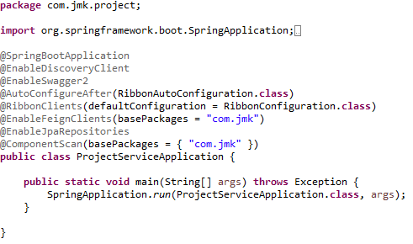

1. Rest ProjectApi with its implementation ProjectApiController

ProjectApi.java

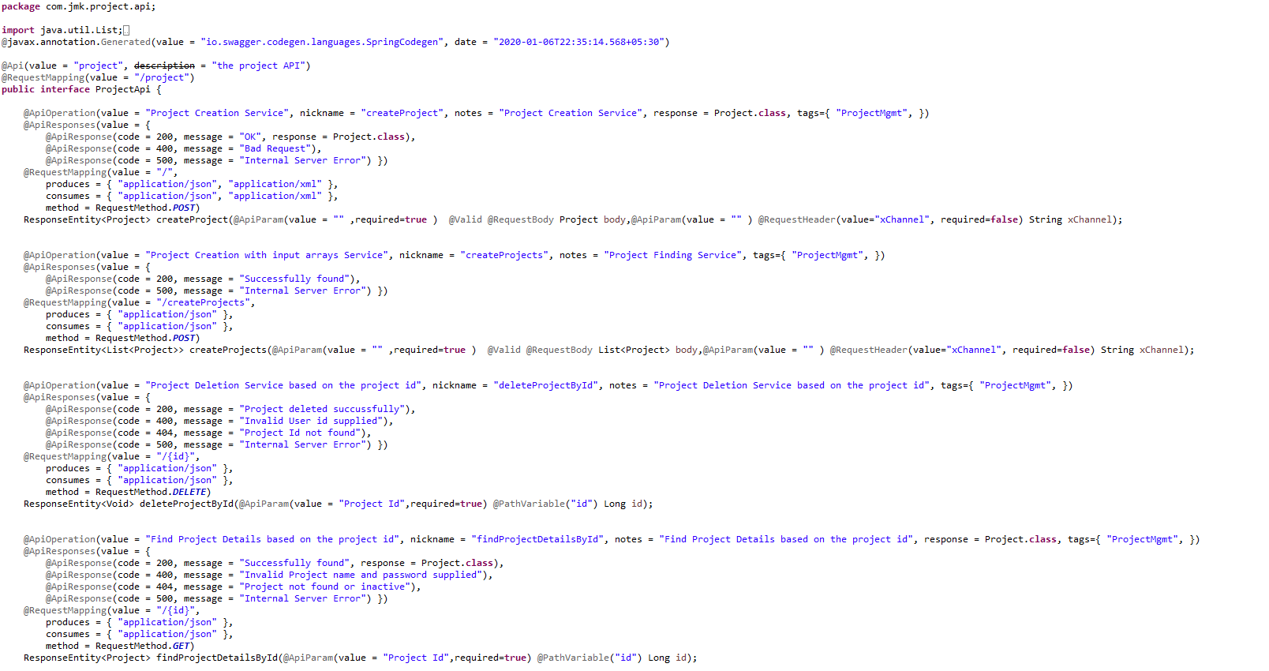

ProjectApiController.java

We can see the use of Feign Client in highlighted colour.

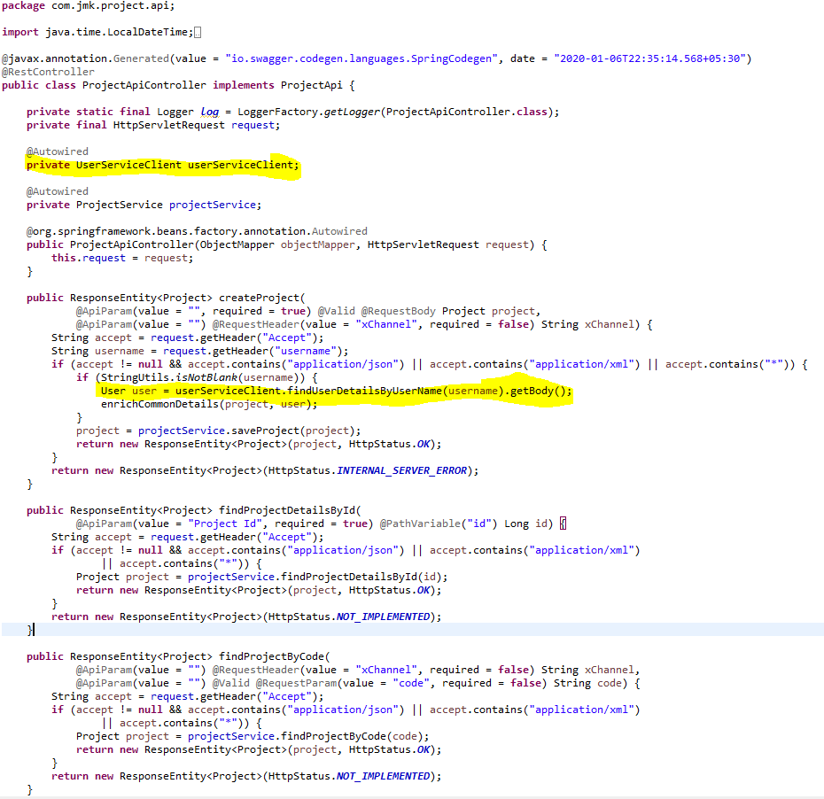

1. Configure the Hazelcast Cache (Embedded Distributed Cache)

* Configure the Hazelcast Cache in the two ways:
  1. If application is running in the Dev environment



* 1. If application is running in the Kubernetes Environment (Prod)



* HazelcastCacheConfiguration.java file to configure the Hazelcast Cache.

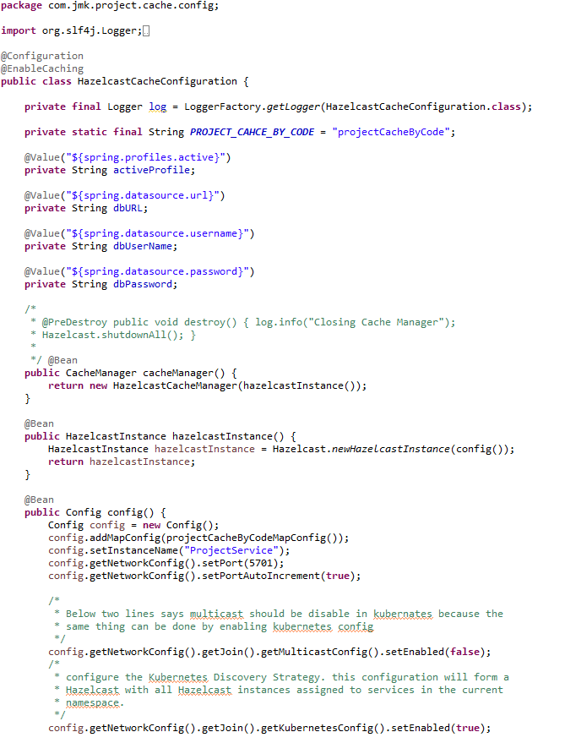

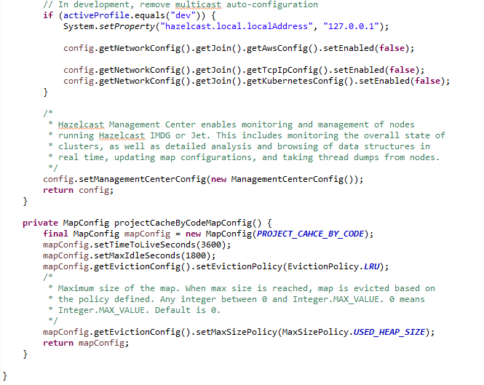

1. UserServiceClient – Feign Client for communicating user-service

Feign dynamically generates the implementation of the interface we created, so Feign has to know which service to call beforehand. That's why we need to give a name for the interface, which is the {Service-Id} of UserServiceClient. Now, Feign contacts the Eureka server with this Service Id, resolves the actual IP/hostname of the UserServiceClient, and calls the URL provided in Request Mapping.

To send HTTP Request to a destination **user-service** Microservice we will need to create a Feign Client interface. Please note the use of @FeignClient annotation which accepts the name user-mgmt-service under which the destination Microservice is registered with Eureka Discovery Service.

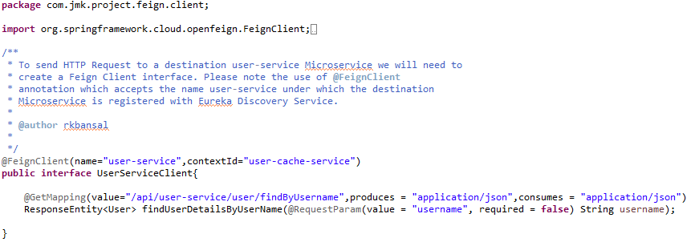

1. If we get an unexpected surprise… The discovery across all namespaces does not work for the Ribbon client. It only works for DiscoveryClient. I think that Ribbon auto-configuration should respect the property spring.cloud.kubernetes.discovery.all-namespaces, but in that case we don’t have any other choice than prepare a workaround. Our workaround is to override Ribbon client auto-configuration provided within Spring Cloud Kubernetes. We are using DiscoveryClient directly for it as shown below.

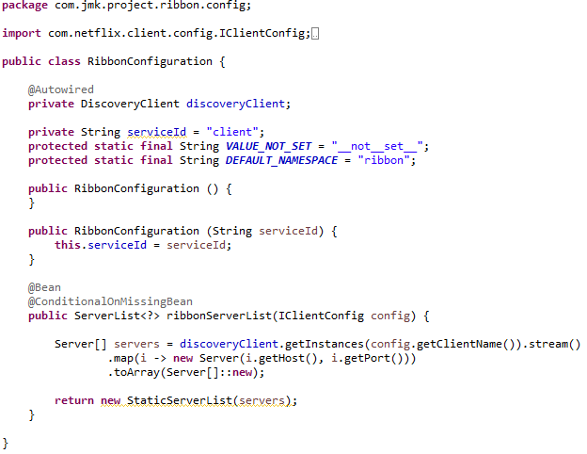

1. Project Service should be exposed as following:

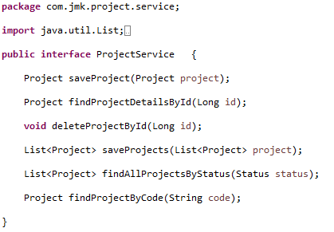

1. Project Service Implementation should be exposed as following:
   1. Custom Exception Handling where EntityNotFoundException class (created in common-service) thrown if entity not present in database which is handled in RestExcceptionHandler(created in common-service), in this handler we are creating the appropriate error message in json and send back to client.
   2. Implementations of Hazelcast Cache.

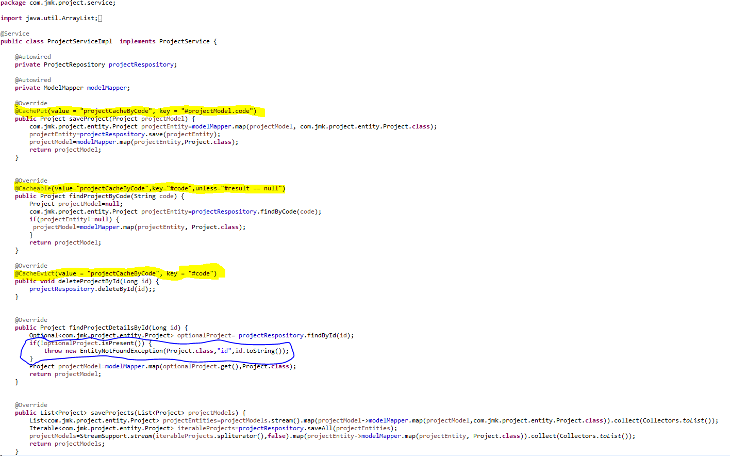

1. ProjectRepository.java

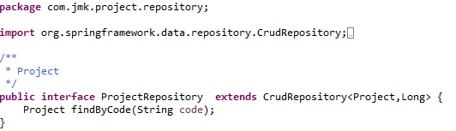

1. Create the model and entities using Lombok.

@**JsonProperty** is suitable for conversion during **serialization**.

@**ApiModelProperty** is **used** for interface document display.

**@Data //It is combination of @ToString, @EqualsAndHashCode ,@Getter,@Setter and @RequiredArgsConstructor**

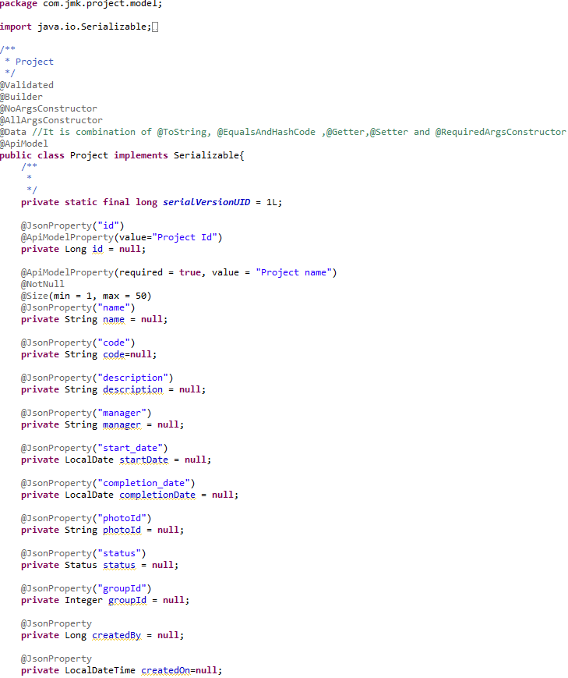

* Made changes in the SwaggerDocumentationConfig

@EnableSwagger2 - Annotation to Enable Swagger Documentation on the API

@EnableSwagger2

@Configuration

**public** **class** SwaggerDocumentationConfig {

ApiInfo apiInfo() {

**return** **new** ApiInfoBuilder()

.title("Project Management Service API")

.description("No description provided (generated by Swagger Codegen https://github.com/swagger-api/swagger-codegen)")

.license("")

.licenseUrl("http://unlicense.org")

.termsOfServiceUrl("")

.version("18.10.0")

.contact(**new** Contact("","", ""))

.build();

}

@Bean

**public** Docket customImplementation(){

**return** **new** Docket(DocumentationType.***SWAGGER_2***)

.select()

.apis(RequestHandlerSelectors.*basePackage*("com.jmk.project.api")).paths(PathSelectors.*regex*("/project.*"))

.build()

.directModelSubstitute(org.threeten.bp.LocalDate.**class**, java.sql.Date.**class**)

.directModelSubstitute(org.threeten.bp.OffsetDateTime.**class**, java.util.Date.**class**)

.apiInfo(apiInfo());

}

}

* Made changes in the Swagger’s HomeController



* After running the application, should be visible following functions for the following url: <http://localhost:5379/api/project-mgmt-service/swagger-ui.html>

Or

<http://localhost:5379/api/project-mgmt-service/api-docs>



### Testing

#### Junit Testing

* Test the Project Api using JUnit



#### Junit Testing

* Run the application as **Spring Boot App** in the following order
  1. EurekaServerApplication
  2. UserServiceApplication
  3. AuthServiceApplication
  4. ZuulGatewayApplication
  5. ProjectMgmtRestApplication
* Open the browser of Eureka Server at localhost:8761, you should see the all the microservices running and enter the url: <http://localhost:8761/>



* Testing
  + Without authentication means directly hitting the project-mgmt-project running on 5379 and getting the details of project based on the status



* + Without authentication means directly hitting the project-mgmt-project running on 5379 and getting the details of project based on the id but not found



* + With authentication means every request to project-mgmt-service microservice will be hit via gateway running 1379
    - with authentication means every request to project-mgmt-service microservice will be hit via gateway running on 1379
      * getting project details with status “A” but without token means no authorization code(Bearer token) in the header will give the error.



* getting project details with status “A” but with token means authorization code(Bearer token) in the header will be provided using authentication service

1. **To get authentication code in response header using authentication service**
2. **Now hit the project-mgmt-service to** get project details with status “A” by providing the token means authorization code(Bearer token) in the header received in above step

* Running the application in Kubernetes Environment

Following are the steps to run the application in the Kubernetes:

* 1. Create the folder k8s which contains the following files:
     + deployment.yaml (in application’s K8s folder)
     + kustomization.yaml (in application’s K8s folder)
     + namespace.yaml (in common K8s folder)
     + rbac.yaml (in common K8s folder)

# People Service

## Description

Create the people-service application as microservice with the following functionalities:

In this microservice, we will create parent class Person having three subclasses Member, Sevadar and Devotee:

Create the member:

While creating member, it will call dependent microservice: **user-mgmt-service** to create the user credentials/information for every member so that member would be able to login into the BJJD application with his details)

2. Update the member

3. Get the list of all the members

4.Delete the member

5.Get the member details

1. Check the member exists:

this method would be invoked from **account-service** to check the member exists or not.

## Entity Relationship Diagram

Create parent class Person having three subclasses Member, Sevadar and Devotee



## Class Diagram

## Use Case Diagram

## Use Case Details

# Darshan Management Service

## Description

* Create the darshan-mgmt-service application as microservice with the following functionalities:
* Saving the details of darshan which includes the Darshan Date, Visitor Details, number of members with Visitor, number of times he visited
  + Validate the visitor if visitor id and donor type is provided in the request. Or If donor is Devotee and its id does not exist in the request.
  + Darshan request is valid otherwise error message should be triggered for the user.
  + Creating the visitor if required: If visitor is devotee and its id does not exist it means we need to create the devotee record first then will save the donation.
  + Saving the donation.
* Saving the details of darshan in bulk
* Updating the darshan details
* Delete the darshan
* Find the darshan by id

## Entity Relationship Diagram

## Class Diagram

## Use Case Diagram

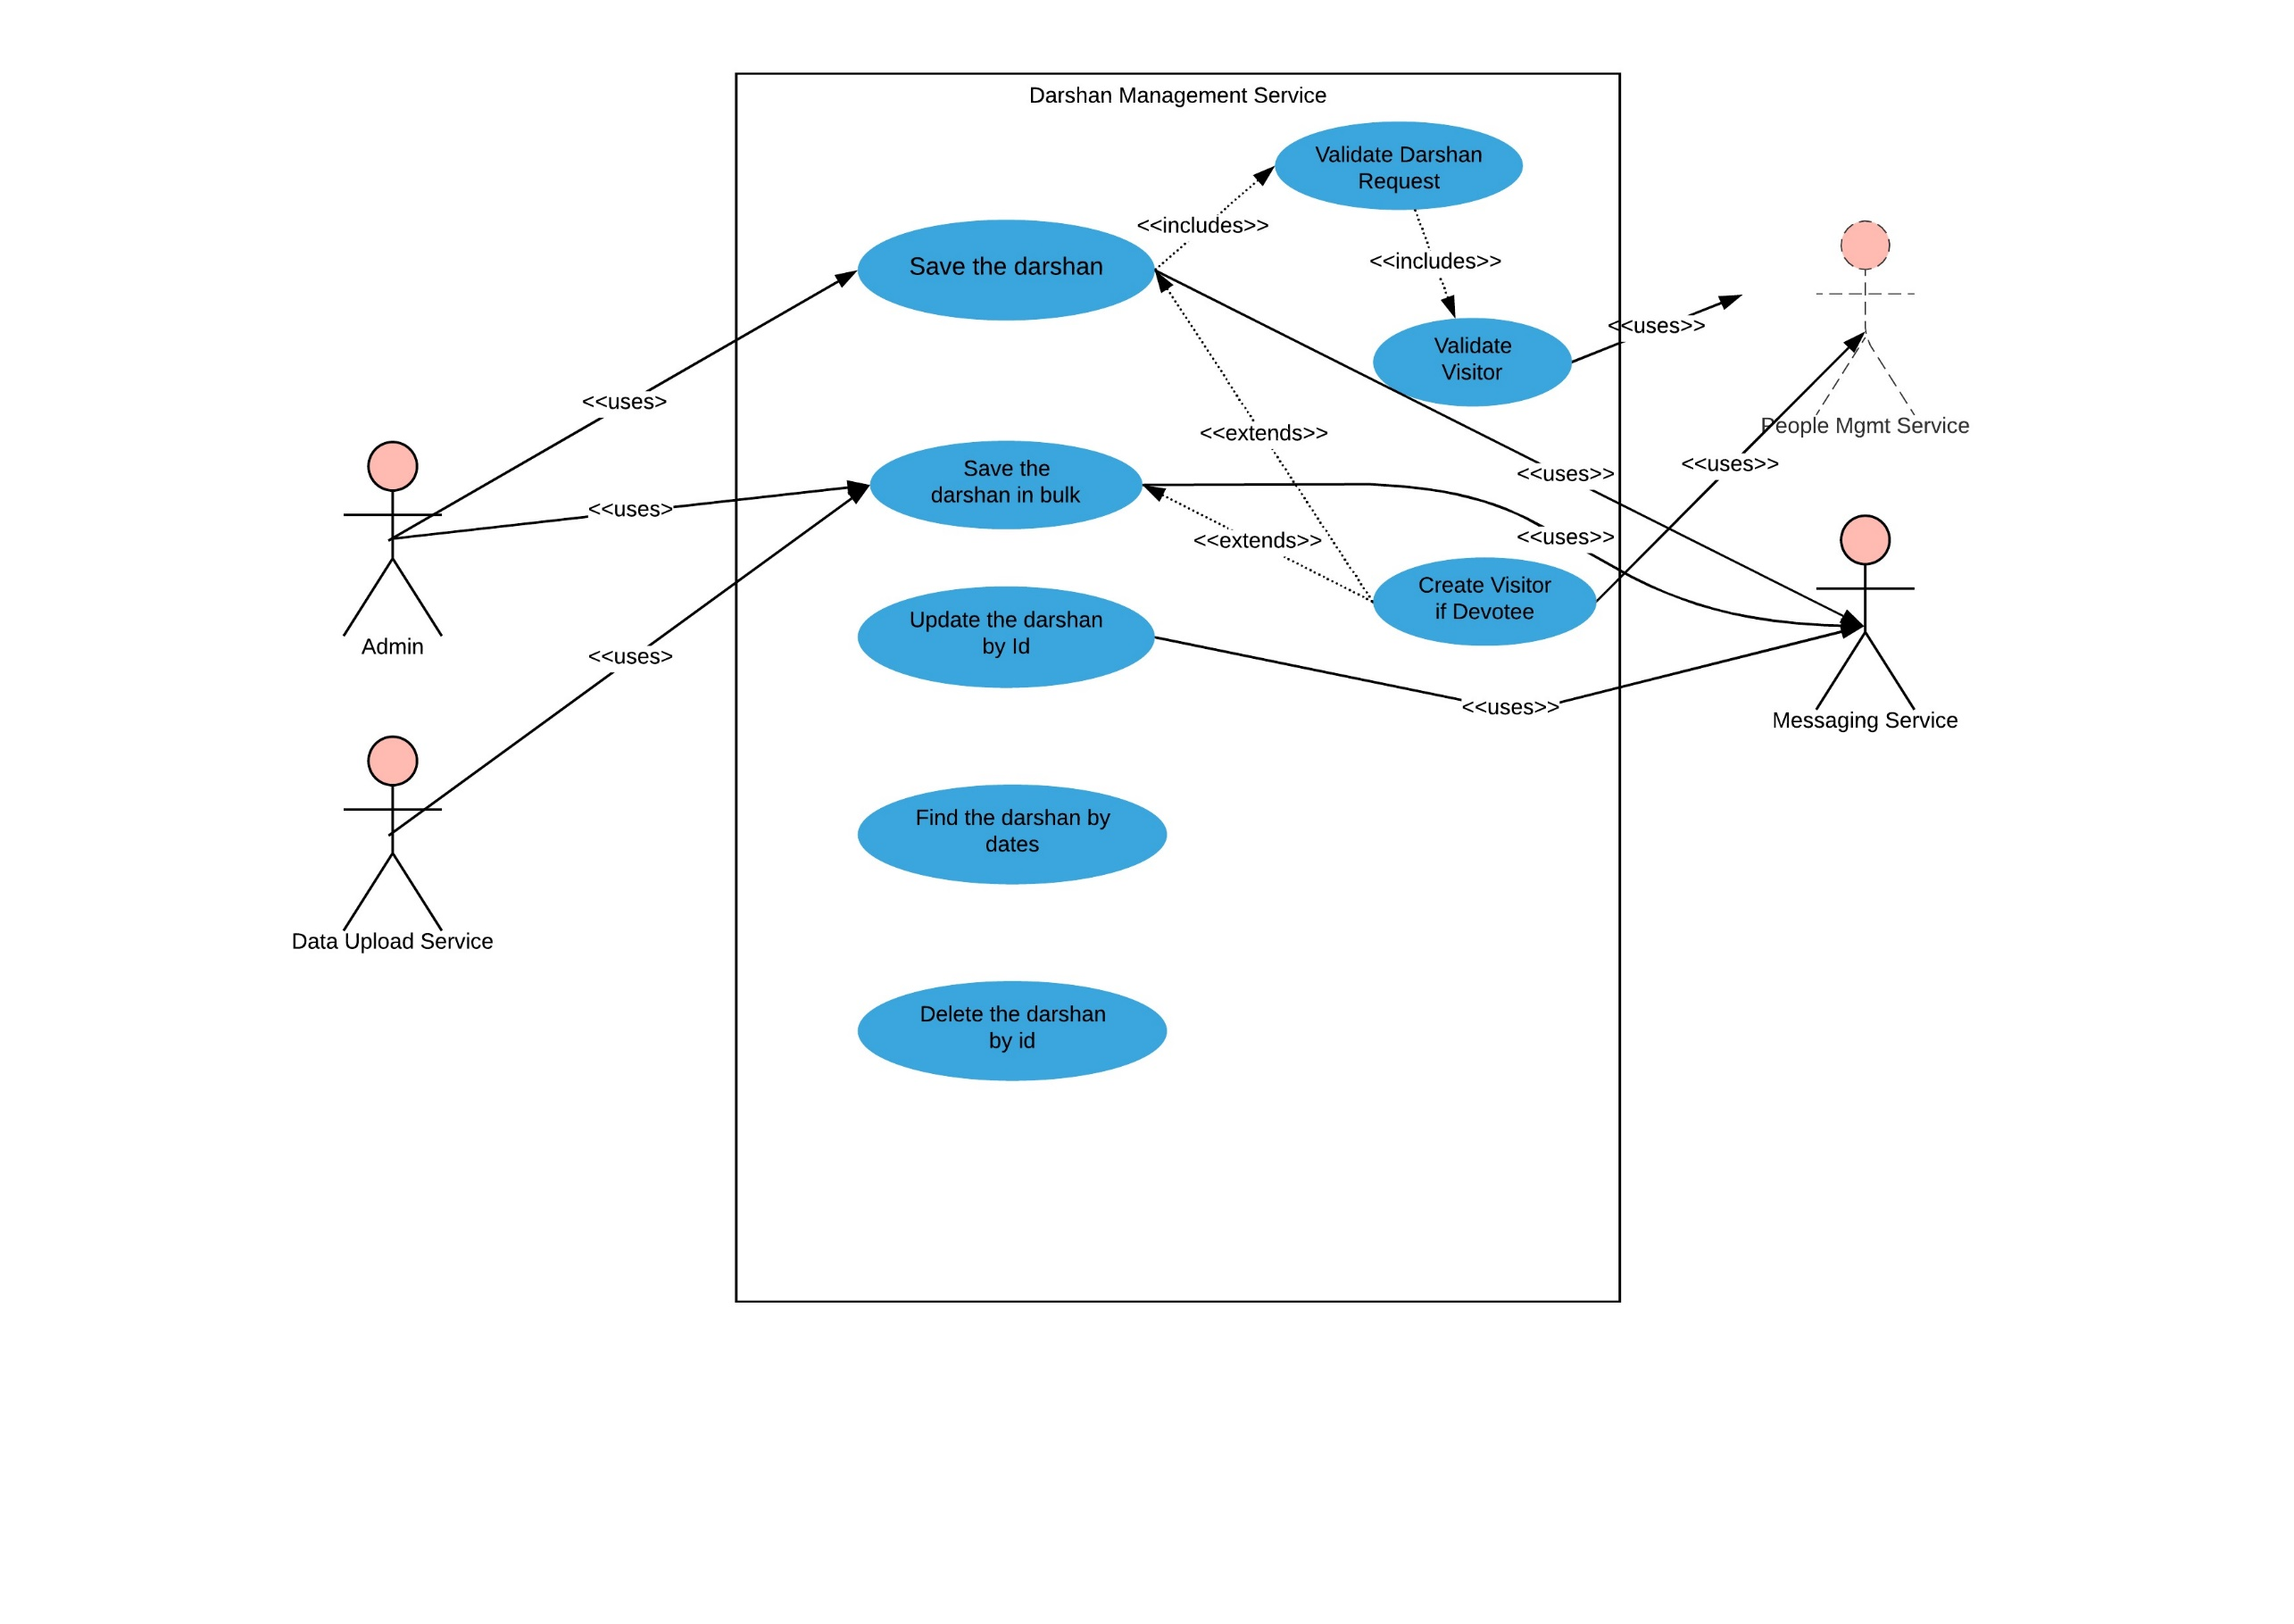

## Use Case Details

# Account Management Service

## Description

An Account Management Service is developed as microservice with the following functionalities:

* Managing Donations
* Managing Expenses

## Entity Relationship Diagram

## Class Diagram

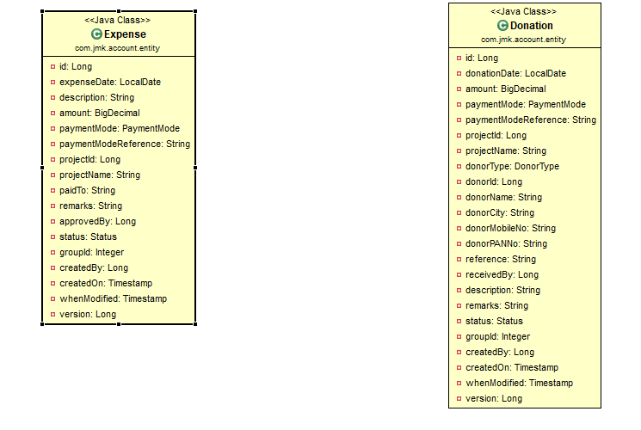

## Use Case Diagram

A use case diagram is a representation of user’s interaction with the system that shows the relationship between the user and the different use cases in which user is involved.

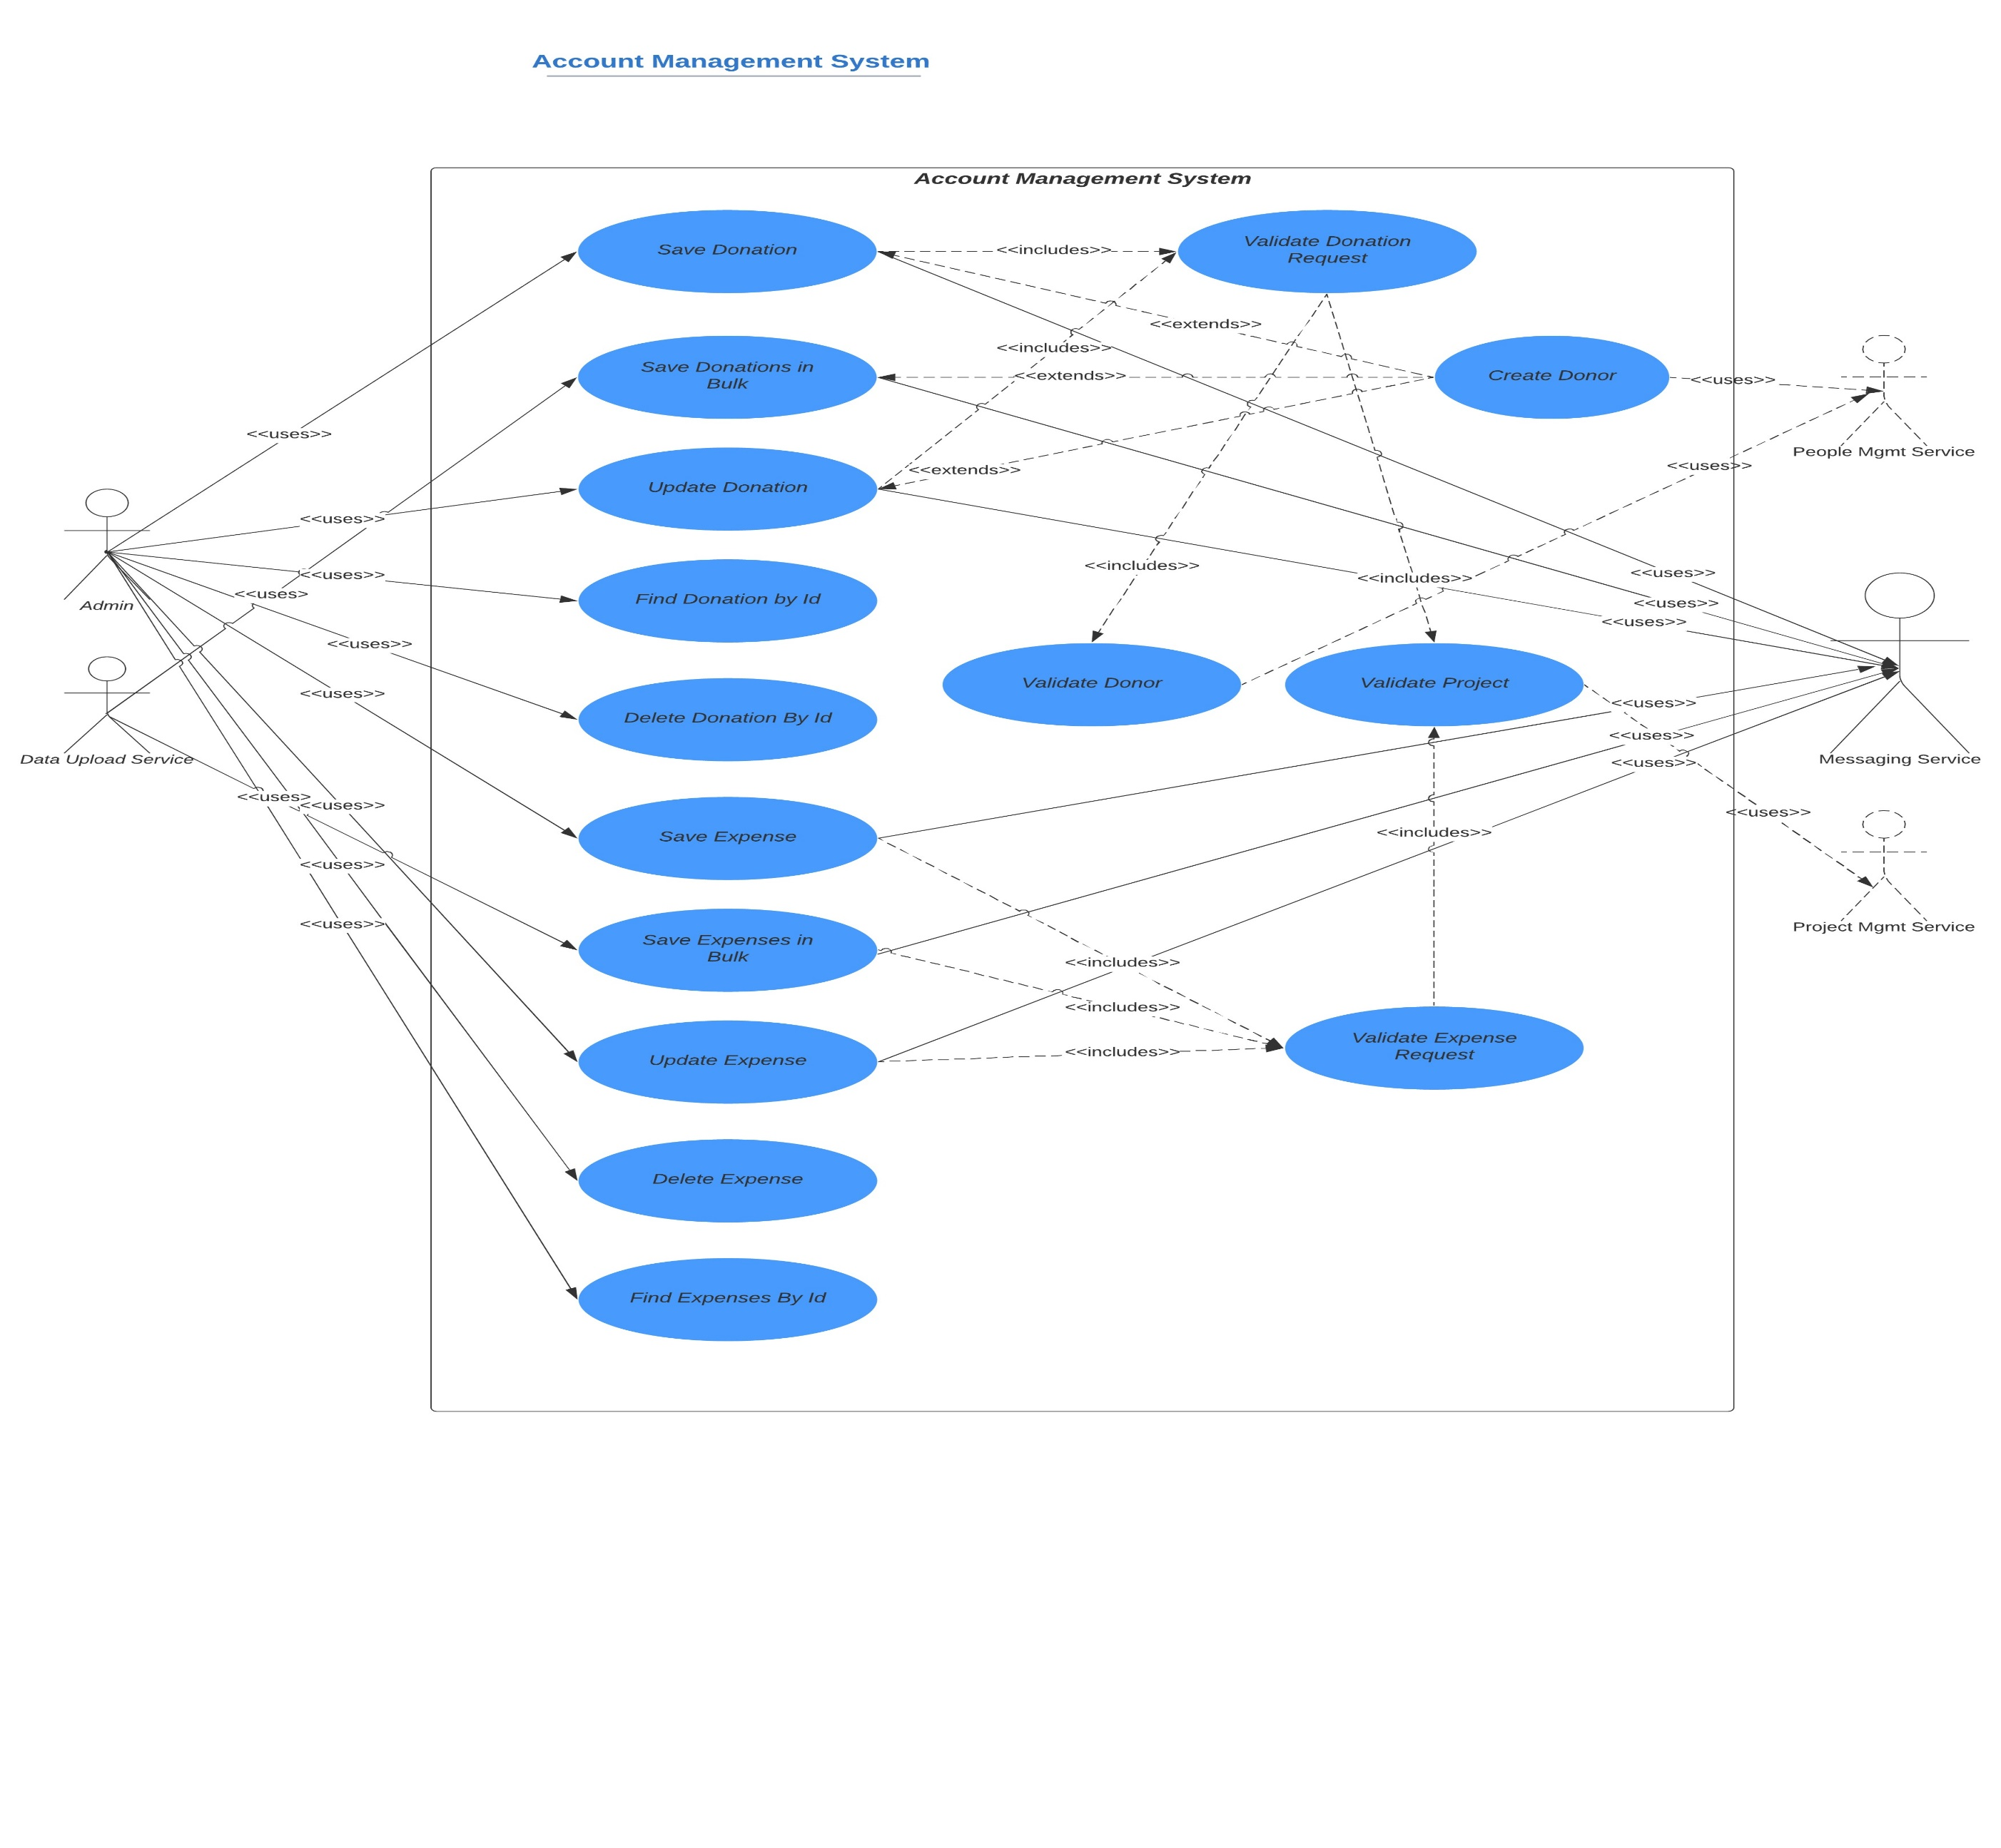

## Microservices Communication

Synch REST Request

Synch REST Request

Account Management System

Synch REST Request

Asynch REST Request

Asynch Kafka/RabbitMQ Request

## Use Case Details

### **Manage the donations**

#### Saving the donation

* Donation Request must be valid.
* If donation Request is valid
* Validate the donor if either of the following conditions met:
  + donor id and donor type are provided in the request and the donor should exists in the system. To check the donor existence, it will interact with **microservice**: people-mgmt-service.
  + If donor is Devotee and its id does not exist in the request.
* Validate the project exists. To check the project existence, it will interact with **microservice**: project-mgmt-service.
* Else If Donation Request Not Valid
* Error message should be triggered for the user.
* Creating the donor if required. If donor is devotee and its id does not exist it means Devotee is new and we need to create the devotee by interacting **microservice**: people-mgmt-service.
* Save the donation and return the saved Donation result.

#### Saving the donations in bulk

* Donation Request must be valid.
* If donation Request is valid
* Validate the donor if either of the following conditions met:
  + donor id and donor type are provided in the request and the donor should exists in the system. To check the donor existence, it will interact with **microservice**: people-mgmt-service.
  + If donor is Devotee and its id does not exist in the request.
* Validate the project exists. To check the project existence, it will interact with **microservice**: project-mgmt-service.
* Else If Donation Request Not Valid
* Error message should be triggered for the user.
* Creating the donor if required. If donor is devotee and its id does not exist it means Devotee is new and we need to create the devotee by interacting **microservice**: people-mgmt-service.
* Save the donation and return the saved Donation result.

#### Update the donation

* Donation Request must be valid.
* If donation Request is valid
* Validate the donor existence:
  + donor id and donor type are provided in the request and the donor should exists in the system. To check the donor existence, it will interact with **microservice**: people-mgmt-service.
* Validate the project exists. To check the project existence, it will interact with **microservice**: project-mgmt-service.
* Else If Donation Request Not Valid
* Error message should be triggered for the user.
* Update the donation request and return the updated Donation result.

#### Find the donation results based on the Id

To get the donation results by providing donation id.

#### Delete the donation based on the Id

To delete the donation by providing the donation id.

### **Manage the expenses**

#### Saving the expense

* Expense Request must be valid.
* If expense Request is valid
* Validate the donor if either of the following conditions met:
  + donor id and donor type are provided in the request and the donor should exists in the system. To check the donor existence, it will interact with **microservice**: people-mgmt-service.
  + If donor is Devotee and its id does not exist in the request.
* Validate the project exists. To check the project existence, it will interact with **microservice**: project-mgmt-service.
* Else If Donation Request Not Valid
* Error message should be triggered for the user.
* Creating the donor if required. If donor is devotee and its id does not exist it means Devotee is new and we need to create the devotee by interacting **microservice**: people-mgmt-service.
* Save the donation and return the saved Donation result.

#### Saving the expenses in bulk

* Donation Request must be valid.
* If donation Request is valid
* Validate the donor if either of the following conditions met:
  + donor id and donor type are provided in the request and the donor should exists in the system. To check the donor existence, it will interact with **microservice**: people-mgmt-service.
  + If donor is Devotee and its id does not exist in the request.
* Validate the project exists. To check the project existence, it will interact with **microservice**: project-mgmt-service.
* Else If Donation Request Not Valid
* Error message should be triggered for the user.
* Creating the donor if required. If donor is devotee and its id does not exist it means Devotee is new and we need to create the devotee by interacting **microservice**: people-mgmt-service.
* Save the donation and return the saved Donation result.

#### Update the expense

* Donation Request must be valid.
* If donation Request is valid
* Validate the donor existence:
  + donor id and donor type are provided in the request and the donor should exists in the system. To check the donor existence, it will interact with **microservice**: people-mgmt-service.
* Validate the project exists. To check the project existence, it will interact with **microservice**: project-mgmt-service.
* Else If Donation Request Not Valid
* Error message should be triggered for the user.
* Update the donation request and return the updated Donation result.

#### Find the expense results based on the Id

#### Delete the expense based on the Id

# Data Upload Service

## Description

## Entity Relationship Diagram

## Class Diagram

## Use Case Diagram

## Use Case Details

# Messaging Service

## Description

## Entity Relationship Diagram

## Class Diagram

## Use Case Diagram

## Use Case Details